**NASH Fire Rated Light Gauge Steel Frame Walls - Type W1**

**(Ambient Temperature Axial Compression Capacities of Gypsum Plasterboard Lined 75 and 90 mm Lipped Channels and 100 and 150 C-Purlins)**

**Report 4**

**April 2018**

**By**

**Anthony Ariyanayagam**

**Mahen Mahendran**



**School of Civil Engineering and Built Environment**

**Science and Engineering Faculty**

**Queensland University of Technology**

**Table of Contents**

NASH Fire Rated Light Gauge Steel Frame Walls 3

1.0. Light Gauge Steel Frame Wall (LSF) Configurations 3

2.0. Structural Finite Element Analysis 4

3.0. Concluding Remarks and Application of Results 38

References 40

**List of Figures**

Figure 1: LSF Wall Stud 5

Figure 2: Buckling Modes of 75x35x8 mm Lipped Channel Studs – Models A, B and C 7

Figure 3: Buckling Modes of 75x35x8 mm Lipped Channel Studs – Models D and E 8

Figure 4: Buckling Modes of 90x35x8 mm Lipped Channel Studs – Models F, G and H 9

Figure 5: Buckling Modes of 90x35x8 mm Lipped Channel Studs – Models I and J 10

Figure 6: Buckling Modes of 100-C Purlins – Models K, L, M and N 11

Figure 7: Buckling Modes of 150-C Purlins – Models O, P, Q and R 12

Figure 8: Loading and Boundary Conditions of 3 m Long Stud Finite Element Model 13

Figure 9: Load versus Axial Deformation Curves from Finite Element Analyses 14

Figure 10: Finite Element Analyses of 75×35×8×0.55 mm G550 Lipped Channel Stud

Model A 18

Figure 11: Finite Element Analyses of 75×35×8×0.75 mm G550 Lipped Channel Stud

Model B 19

Figure 12: Finite Element Analyses of 75×35×8×1.00 mm G550 Lipped Channel Stud

Model C 20

Figure 13: Finite Element Analyses of 75×35×8×1.20 mm G500 Lipped Channel Stud

Model D 21

Figure 14: Finite Element Analyses of 75×35×8×1.60 mm G450 Lipped Channel Stud

Model E 22

Figure 15: Finite Element Analyses of 90×35×8×0.55 mm G550 Lipped Channel Stud

Model F 23

Figure 16: Finite Element Analyses of 90×35×8×0.75 mm G550 Lipped Channel Stud

Model G 24

Figure 17: Finite Element Analyses of 90×35×8×1.00 mm G550 Lipped Channel Stud

Model H 25

Figure 18: Finite Element Analyses of 90×35×8×1.20 mm G500 Lipped Channel Stud

Model I 26

Figure 19: Finite Element Analyses of 90×35×8×1.60 mm G450 Lipped Channel Stud

Model J 27

Figure 20: Finite Element Analyses of 102x51x12.5x1.00 mm G550 C-Purlin – Model K 28

Figure 21: Finite Element Analyses of 102x51x12.5x1.20 mm G500 C-Purlin – Model L 29

Figure 22: Finite Element Analyses of 102x51x13.5x1.50 mm G450 C-Purlin – Model M 30

Figure 23: Finite Element Analyses of 102x51x14.5x1.90 mm G550 C-Purlin – Model N 31

Figure 24: Finite Element Analyses of 152x64x14.5x1.20 mm G500 C-Purlin – Model O 32

Figure 25: Finite Element Analyses of 152x64x15.5x1.50 mm G450 C-Purlin – Model P 33

Figure 26: Finite Element Analyses of 152x64x16.5x1.90 mm G450 C-Purlin – Model Q 34

Figure 27: Finite Element Analyses of 152x64x18.5x2.40 mm G450 C-Purlin – Model R 35

**List of Tables**

Table 1: LSF Wall Configurations – Wall Type W1 3

Table 2: LSF Wall Stud Centerline Dimensions and Section Properties 6

Table 3: Buckling Loads of Wall Studs Lined with Gypsum Plasterboards 16

Table 4: Ultimate Axial Compression Capacities of Wall Studs Lined with Gypsum Plasterboards 17

Table 5: Comparison of FE Analysis Results with Predictions from DSM based Design Rules in AS/NZS 4600 for Type W1 LSF Wall Studs lined with Gypsum Plasterboards on Both Sides 37

Table 6: Ultimate Axial Compression Capacities of Type W1 LSF Wall Studs with Gypsum Plasterboards on Both Sides 39

# NASH Fire Rated Light Gauge Steel Frame Walls

# Light Gauge Steel Frame Wall (LSF) Configurations

This report presents the details of structural Finite Element (FE) analyses conducted on the ambient temperature axial compression capacities of load bearing LSF walls made of lipped channel and C-purlin studs. It includes the details of the structural FE model descriptions, analysis procedures and results, in particular, the ultimate load carrying capacities of 3 m long studs in Type-W1 LSF walls. Also, the assumptions and limitations of the FE models used in this study are described in the relevant sections of this report. Table 1 lists the details of the LSF wall studs included in this report.

Table 1: LSF Wall Configurations – Wall Type W1

|  |  |  |  |  |  |
| --- | --- | --- | --- | --- | --- |
| Stud FE Model No | LSF Wall Panels | | | Yield Strength (MPa) | Elastic Modulus (MPa) |
| Stud Size  (External Dimensions) | Stud Thickness (mm) | Grade |
| Model A | 75x35x8 Lipped Channel Stud | 0.55 | G550 | 550 | 200,000 |
| Model B | 0.75 | G550 | 550 |
| Model C | 1.00 | G550 | 550 |
| Model D | 1.20 | G500 | 500 |
| Model E | 1.60 | G450 | 450 |
| Model F | 90x35x8 Lipped Channel Stud | 0.55 | G550 | 550 |
| Model G | 0.75 | G550 | 550 |
| Model H | 1.00 | G550 | 550 |
| Model I | 1.20 | G500 | 500 |
| Model J | 1.60 | G450 | 450 |
| Model K | 100 C-Purlin  (102x51x12.5 mm) | 1.00 | G550 | 550 |
| Model L | 1.20 | G500 | 500 |
| Model M | 100 C-Purlin  (102x51x13.5 mm) | 1.50 | G450 | 450 |
| Model N | 100 C-Purlin  (102x51x14.5 mm) | 1.90 | G450 | 450 |
| Model O | 150 C-Purlin  (152x64x14.5 mm) | 1.20 | G500 | 500 |
| Model P | 150 C-Purlin  (152x64x15.5 mm) | 1.50 | G450 | 450 |
| Model Q | 150 C-Purlin  (152x64x16.5 mm) | 1.90 | G450 | 450 |
| Model R | 150 C-Purlin  (152x64x18.5 mm) | 2.40 | G450 | 450 |

# 2.0. Structural Finite Element Analysis

The commercially available general purpose finite element program Abaqus Version 6.14-2 was used in the development of finite element models of lipped channel and C-purlin studs lined with gypsum plasterboards.

The shell element type S4R was used to model the wall stud while the Multiple Point Constraints (MPC) was used to model the constraints. S4R shell elements of 4 mm x 4 mm were used. S4R is a robust, general-purpose and four node quadrilateral shell element suitable for a wide range of applications with reduced integration to avoid shear and membrane locking. The element type and mesh size were selected based on the previous finite element studies conducted by Gunalan and Mahendran (2013) and Ariyanayagam and Mahendran (2014) for similar conditions.

Figure 1 and Table 2 show the stud dimensions and section properties of the studs considered in this report. Section properties were obtained from the CUFSM finite strip analyses and corresponding stud buckling modes are also shown in Figures 2 to 7.

Figure 8 shows the boundary conditions of the stud and the finite element mesh used in the analysis. The displacements at the ends of the stud were restrained about the two major axes (x & y) while twisting was restrained about the z-axis. The axial displacement was restrained along the z-axis at one end (bottom support). The lateral restraint provided by the gypsum plasterboard was included along the stud at 300 mm spacing on both flanges by restraining the in-plane lateral displacement (x-axis) at the gypsum plasterboard-stud screw fastening points. Nominal mechanical property values shown in Table 1 with Poisson’s ratio of 0.3 were used in the analyses.

Both bifurcation buckling and non-linear analyses were conducted using Abaqus. The bifurcation buckling analysis was performed first for the stud sections and the elastic buckling modes were determined. Table 3 gives the buckling loads of wall studs lined with gypsum plasterboards obtained from both CUFSM and Abaqus analyses. The relevant buckling modes were then used to include the initial geometric imperfections in the nonlinear analyses using the Riks-ON method, which is a force induced loading based non-linear static analysis. An initial local imperfection amplitude of *0.006b* for the stiffened element and global imperfection amplitude of *l/1000* were used based on the lowest buckling modes, where *b* and *l* are the width of the plate element and the length of the stud.

Figure 9 shows the load versus axial deformation curves of the studs obtained from the finite element analyses. Table 4 summarises the finite element analysis predicted axial compression capacities of stud walls lined with gypsum plasterboards. As seen in Figure 9, the load versus axial deformation curves of some thin stud sections did not converge when Riks-ON method of non-linear static analysis was used. This could have been due to possible mesh distortion as a result of very thin elements in load control Riks-ON method of analysis. To overcome this numerical problem non-linear General Static method of analysis was used with the displacement control constraints for those FE models. An axial displacement was applied to one end (top support) and allowed to increase from zero to a maximum of 0.1 m in increments and the reaction load at the other end (bottom support) was recorded. Load (reaction load at bottom support) versus axial deformation curves converged and are shown in Figure 9. The corresponding stud failure loads are shown in Table 4. Thus it confirms the ultimate failure loads of the studs. Figures 10 to 27 show the lowest buckling mode and the ultimate failure modes obtained from the finite element analyses of the stud sections considered in this report.

a

b

c

d

e

*Note: a = e and b=d, and are centreline dimensions shown in Table 2*

X

Y

**Figure 1: LSF Wall Stud**

Table 2: LSF Wall Stud Centerline Dimensions and Section Properties

|  |  |  |  |  |  |  |  |  |  |
| --- | --- | --- | --- | --- | --- | --- | --- | --- | --- |
| Stud FE Model No | Stud Size  (External Dimensions) | Stud Centerline Dimensions (mm) | | | | Section Properties | | | |
| Thickness | a | b | c | Xcg (mm) | Ag  (mm2) | Ixx  (mm4) | Iyy  (mm4) |
| Model A | 75x35x8 Lipped Channel Stud | 0.55 | 7.725 | 34.45 | 74.45 | 10.825 | 87.37 | 80,925.2 | 14,841.1 |
| Model B | 0.75 | 7.625 | 34.25 | 74.25 | 10.730 | 118.50 | 109,140.3 | 19,861.8 |
| Model C | 1.00 | 7.500 | 34.00 | 74.00 | 10.612 | 157.00 | 143,514.4 | 25,864.0 |
| Model D | 1.20 | 7.400 | 33.80 | 73.80 | 10.517 | 187.44 | 170,305.4 | 30,451.0 |
| Model E | 1.60 | 7.200 | 33.40 | 73.40 | 10.327 | 247.36 | 222,024.2 | 39,067.1 |
| Model F | 90x35x8 Lipped Channel Stud | 0.55 | 7.725 | 34.45 | 89.45 | 9.891 | 95.59 | 122,836.9 | 15,724.4 |
| Model G | 0.75 | 7.625 | 34.25 | 89.25 | 9.800 | 129.75 | 165,847.0 | 21,044.8 |
| Model H | 1.00 | 7.500 | 34.00 | 89.00 | 9.686 | 172 | 218,383.2 | 27,405.7 |
| Model I | 1.20 | 7.400 | 33.80 | 88.80 | 9.595 | 205.44 | 259,439.7 | 32,267.3 |
| Model J | 1.60 | 7.200 | 33.40 | 88.40 | 7.200 | 271.36 | 338,990.4 | 41,400.2 |
| Model K | 100 C-Purlin  (102x51x12.5 mm) | 1.00 | 12.00 | 50.00 | 101.00 | 16.444 | 225.00 | 388,697.4 | 82,488.9 |
| Model L | 1.20 | 11.90 | 49.80 | 100.80 | 16.348 | 269.04 | 462,785.1 | 97,729.6 |
| Model M | 100 C-Purlin  (102x51x13.5 mm) | 1.50 | 12.75 | 49.50 | 100.50 | 16.500 | 337.50 | 576,006.2 | 123,125.1 |
| Model N | 100 C-Purlin  (102x51x14.5 mm) | 1.90 | 13.55 | 49.10 | 100.10 | 16.599 | 428.26 | 723,406.6 | 156,071.5 |
| Model O | 150 C-Purlin  (152x64x14.5 mm) | 1.20 | 13.90 | 62.80 | 150.80 | 18.704 | 365.04 | 1,356,638.3 | 202,003.0 |
| Model P | 150 C-Purlin  (152x64x15.5 mm) | 1.50 | 14.75 | 62.50 | 150.50 | 18.853 | 457.50 | 1,692,501.0 | 254,389.7 |
| Model Q | 150 C-Purlin  (152x64x16.5 mm) | 1.90 | 15.55 | 62.10 | 150.10 | 18.951 | 580.26 | 2,133,230.0 | 322,819.6 |
| Model R | 150 C-Purlin  (152x64x18.5 mm) | 2.40 | 17.30 | 61.60 | 149.60 | 19.278 | 737.76 | 2,689,395.2 | 414,922.7 |

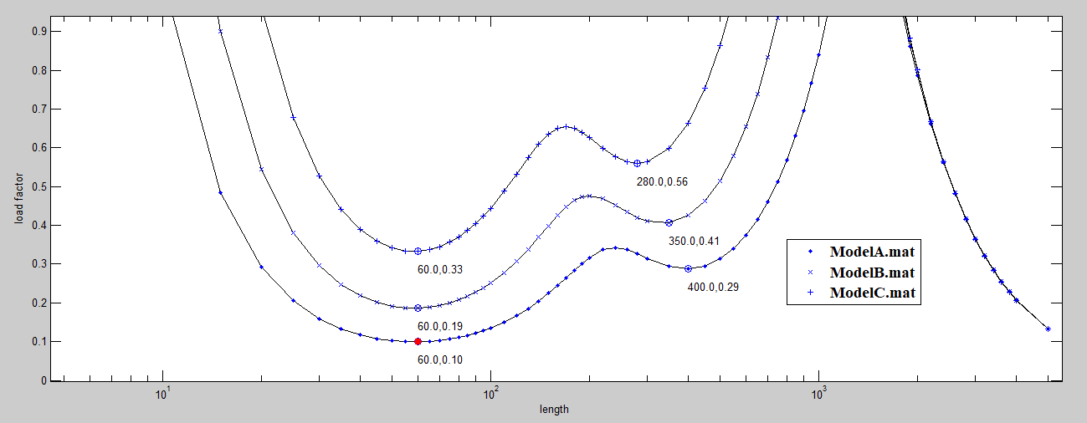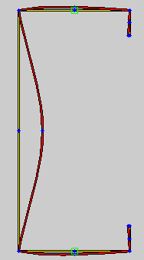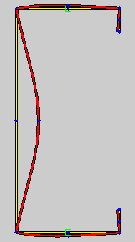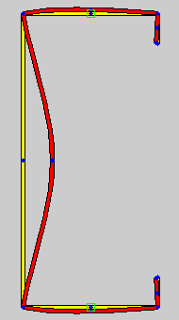

HWL= 60

LF = 0.10

Yield Load = 48.05 kN

HWL= 60

LF = 0.19

Yield Load = 65.18 kN

HWL= 60

LF = 0.33

Yield Load = 86.35 kN

**At 3000 mm**

Note: HWL – Half-wave length

LF – Load Factor = Buckling load / Yield load

Model A

Model B

Model C

Model A

t=0.55 mm

Model B

t=0.75 mm

Model C

t=1.0 mm

Local web buckling

**Figure 2: Buckling Modes of 75x35x8 mm Lipped Channel Studs – Models A, B and C**

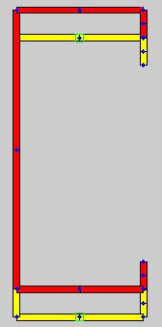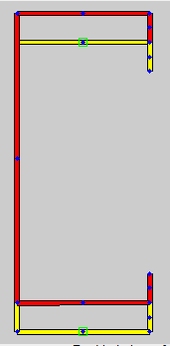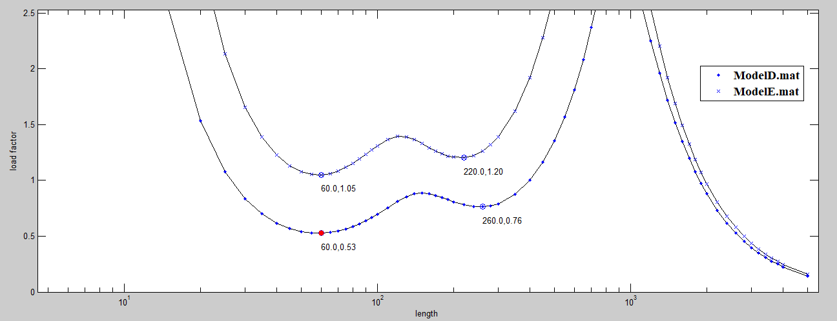

HWL= 3000

LF = 0.40

Yield Load = 93.72 kN

HWL= 3000

LF = 0.44

Yield Load = 111.31 kN

**At 3000 mm**

Note: HWL – Half-wave length

LF – Load Factor = Buckling load / Yield load

Model D

Model E

Model D t=1.20 mm

Model E

t=1.60 mm

Flexural buckling

**Figure 3: Buckling Modes of 75x35x8 mm Lipped Channel Studs – Models D and E**

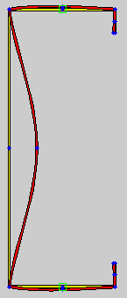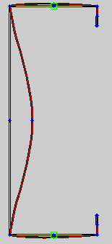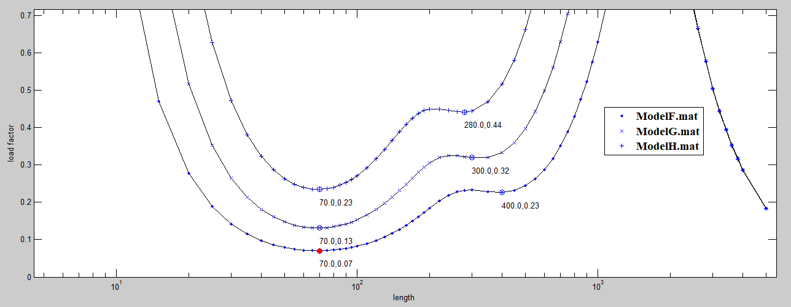

HWL= 70

LF = 0.07

Yield Load = 52.57 kN

HWL= 70

LF = 0.13

Yield Load = 71.36 kN

**At 3000 mm**

Note: HWL – Half-wave length

LF – Load Factor = Buckling load / Yield load

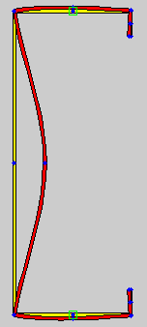

HWL= 70

LF = 0.23

Yield Load = 94.60 kN

Model F

Model G

Model H

Model F

t=0.55 mm

Model G

t=0.75 mm

Model H t=1.0 mm

Local web buckling

**Figure 4: Buckling Modes of 90x35x8 mm Lipped Channel Studs – Models F, G and H**

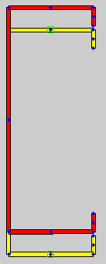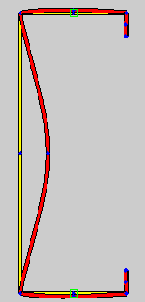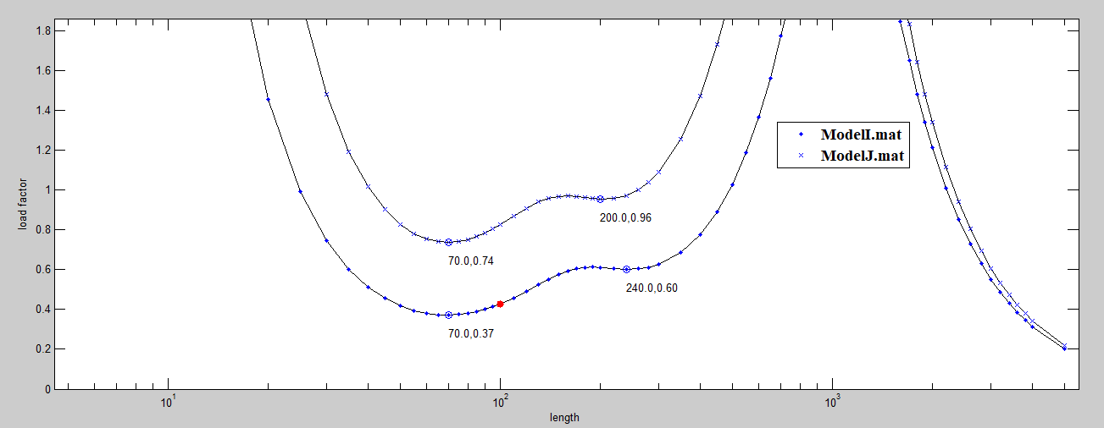

HWL= 70

LF = 0.37

Yield Load = 102.72 kN

HWL= 3000

LF = 0.61

Yield Load = 122.11 kN

**At 3000 mm**

Note: HWL – Half-wave length

LF – Load Factor = Buckling load / Yield load

Model I

Model J

Model I

t=1.2 mm

Model J

t=1.6 mm

Local web buckling

Flexural buckling

**Figure 5: Buckling Modes of 90x35x8 mm Lipped Channel Studs – Models I and J**

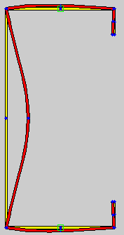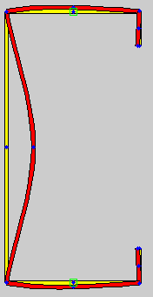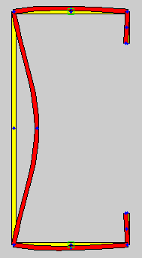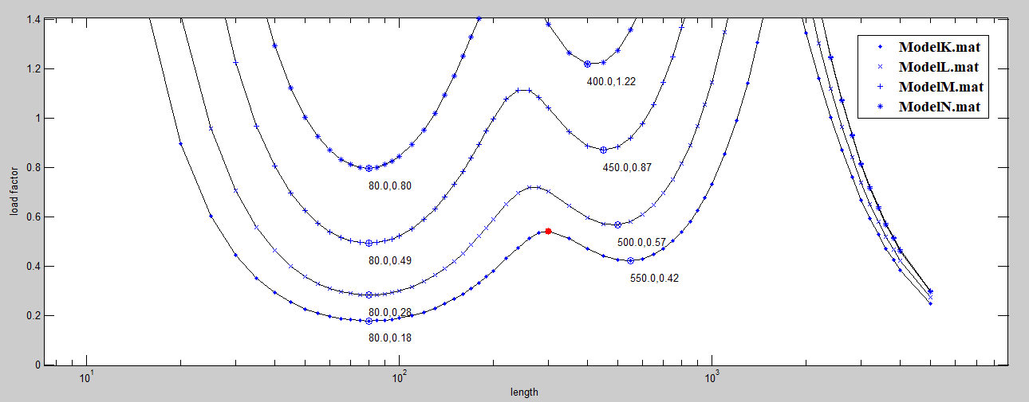

HWL= 80

LF = 0.28

Yield Load = 134.52 kN

HWL= 80

LF = 0.49

Yield Load = 151.88 kN

**At 3000 mm**

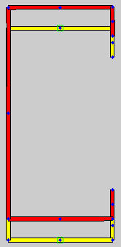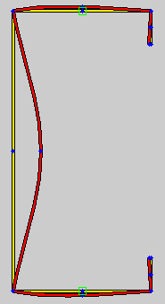

HWL= 80

LF = 0.18

Yield Load = 123.75 kN

HWL= 80

LF = 0.80

HWL= 3000

LF = 0.81

Yield Load = 192.72 kN

Model K

Model L

Model M

Model N

Model N

Model K

t=1.0 mm

Model L

t=1.2 mm

Model M

t=1.5 mm

Model N

t=1.9 mm

Local web buckling

Flexural buckling

Local web buckling

**Figure 6: Buckling Modes of 100-C Purlins – Models K, L, M and N**

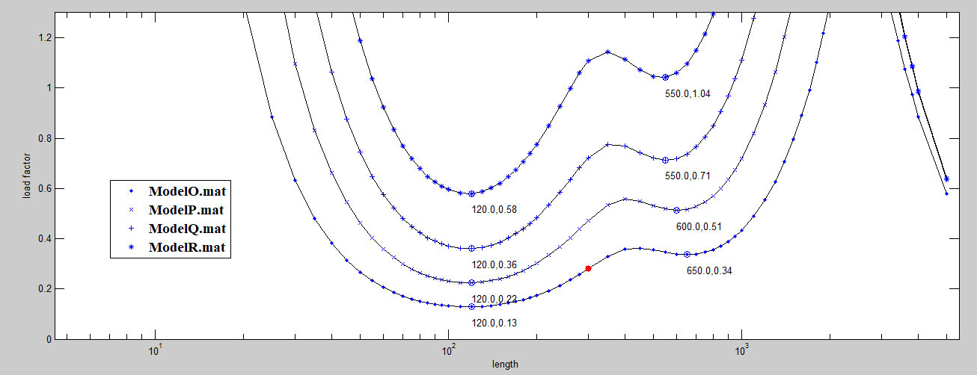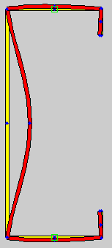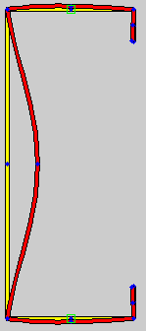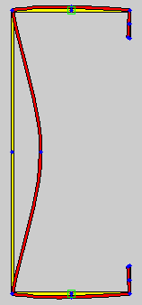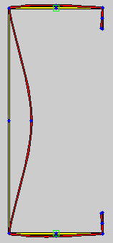

HWL= 120

LF = 0.22

Yield Load = 205.88 kN

HWL= 120

LF = 0.36

Yield Load = 261.12 kN

**At 3000 mm**

HWL= 120

LF = 0.13

Yield Load = 182.52 kN

HWL= 120

LF = 0.58

Yield Load = 331.99 kN

Model O

Model P

Model Q

Model R

Model O

t=1.2 mm

Model P

t=1.5 mm

Model Q

t=1.9 mm

Model R

t=2.4 mm

Local web buckling

**Figure 7: Buckling Modes of 150-C Purlins – Models O, P, Q and R**

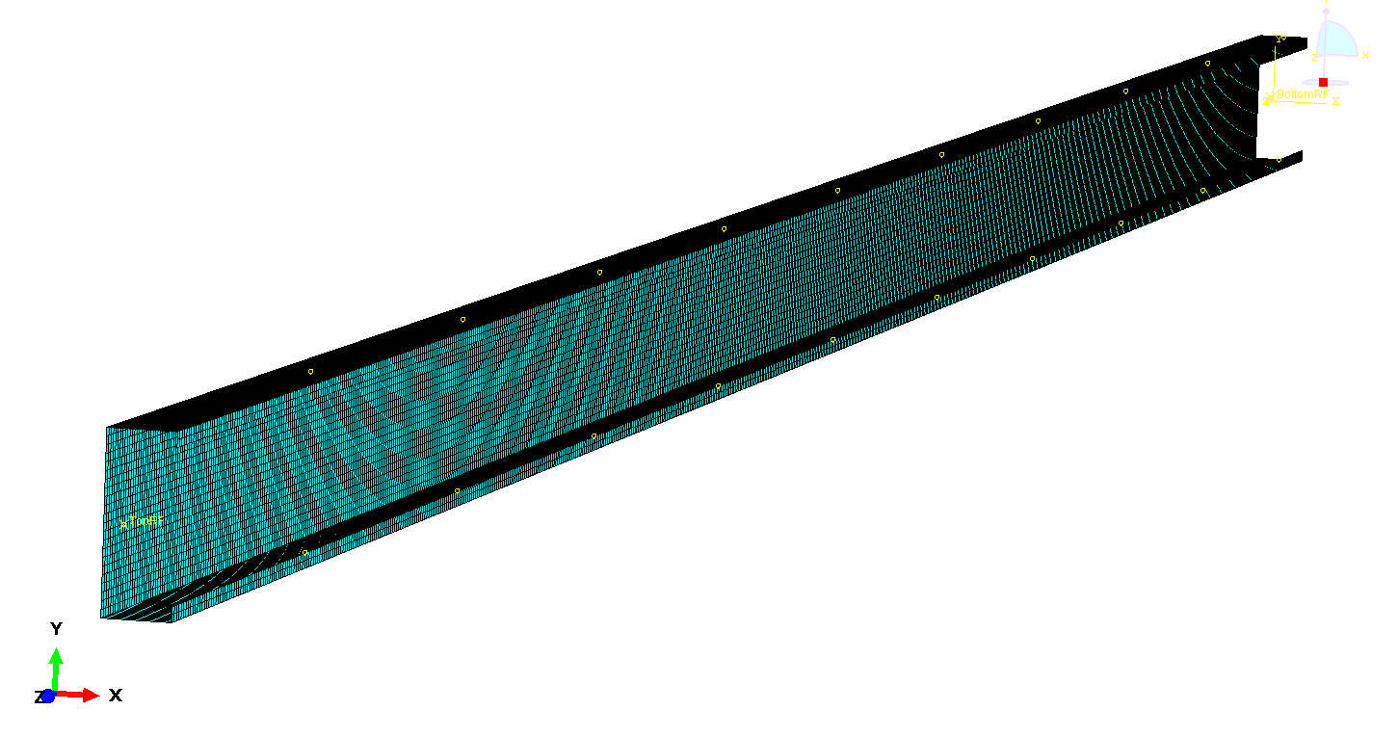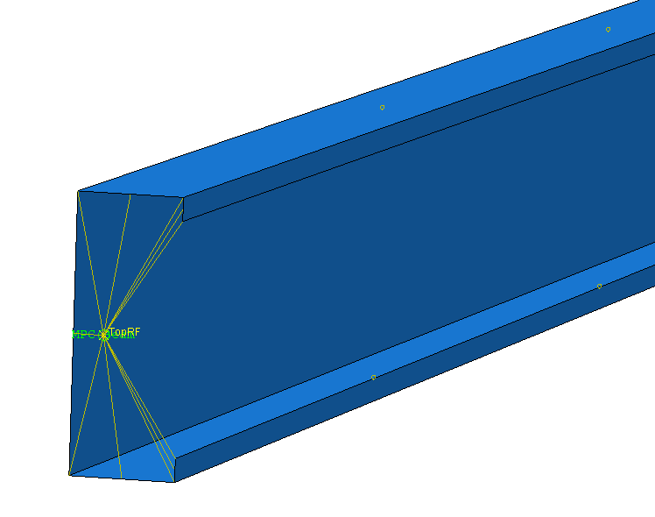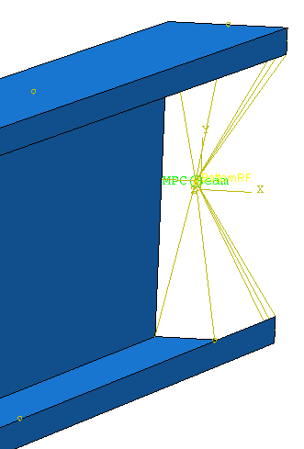

Bottom Support

(DOF ‘1236’)

Top Support and Axial Load (DOF ‘126’)

Lateral restraint provided by the gypsum plasterboard (DOF ‘1’ at 300 mm)

**Figure 8: Loading and Boundary Conditions of 3 m Long Stud Finite Element Model**

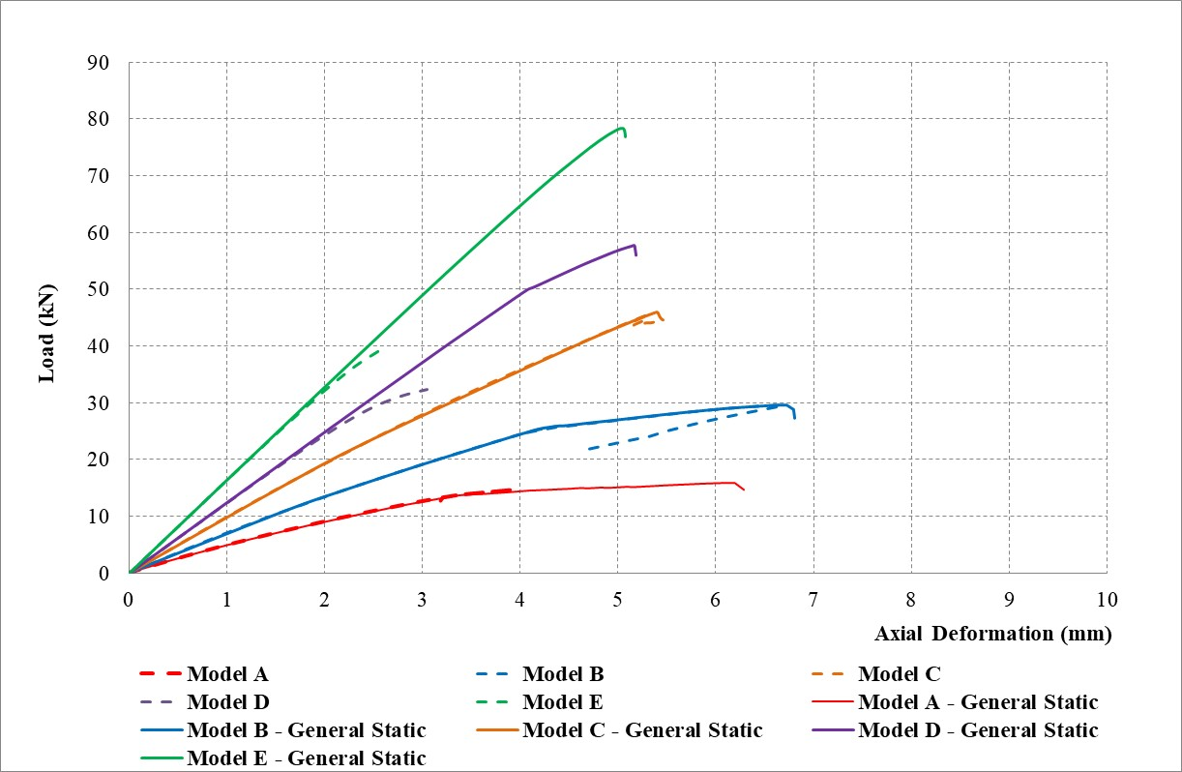

1. 75x35x8 mm Lipped channel studs
2. 90x35x8 mm Lipped channel studs

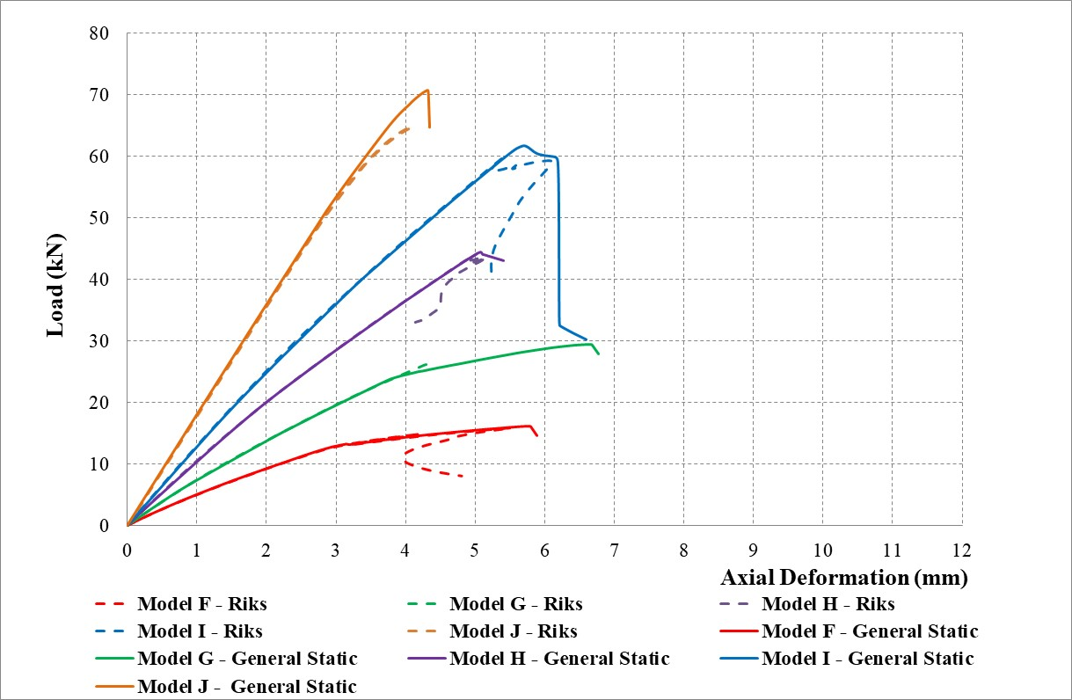

**Model A**

**Model B**

**Model C**

**Model D**

**Model E**

**Model F**

**Model G**

**Model H**

**Model I**

**Model J**

**Figure 9: Load versus Axial Deformation Curves from Finite Element Analyses**

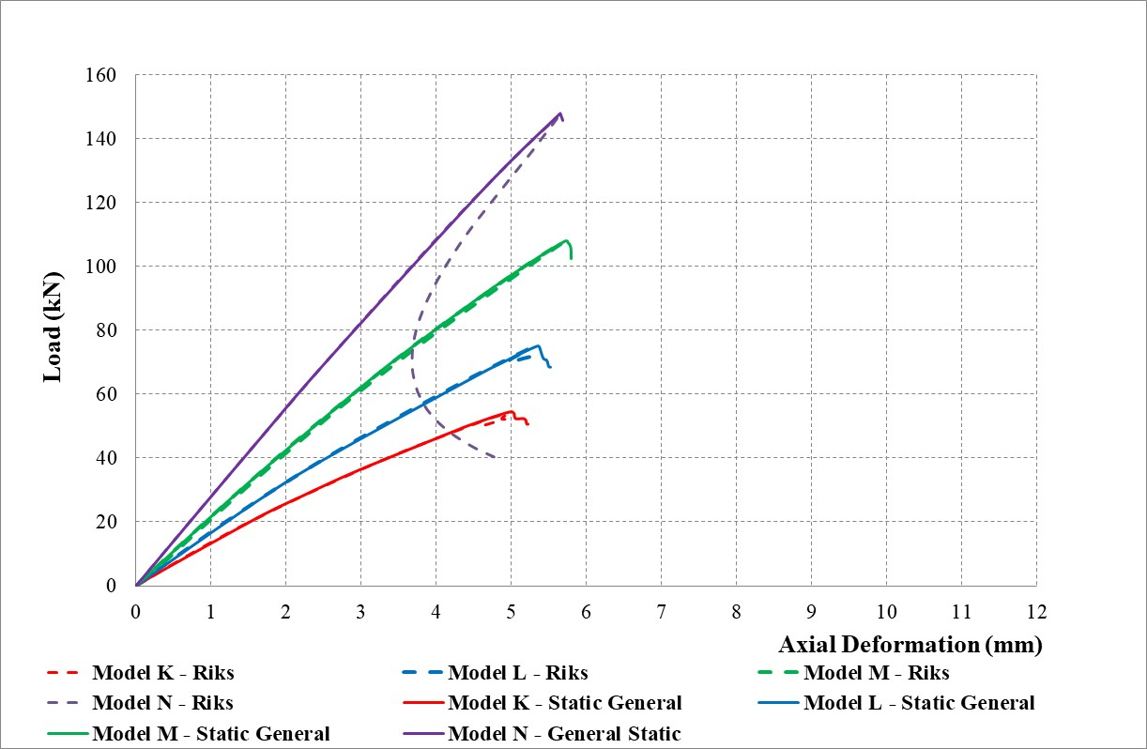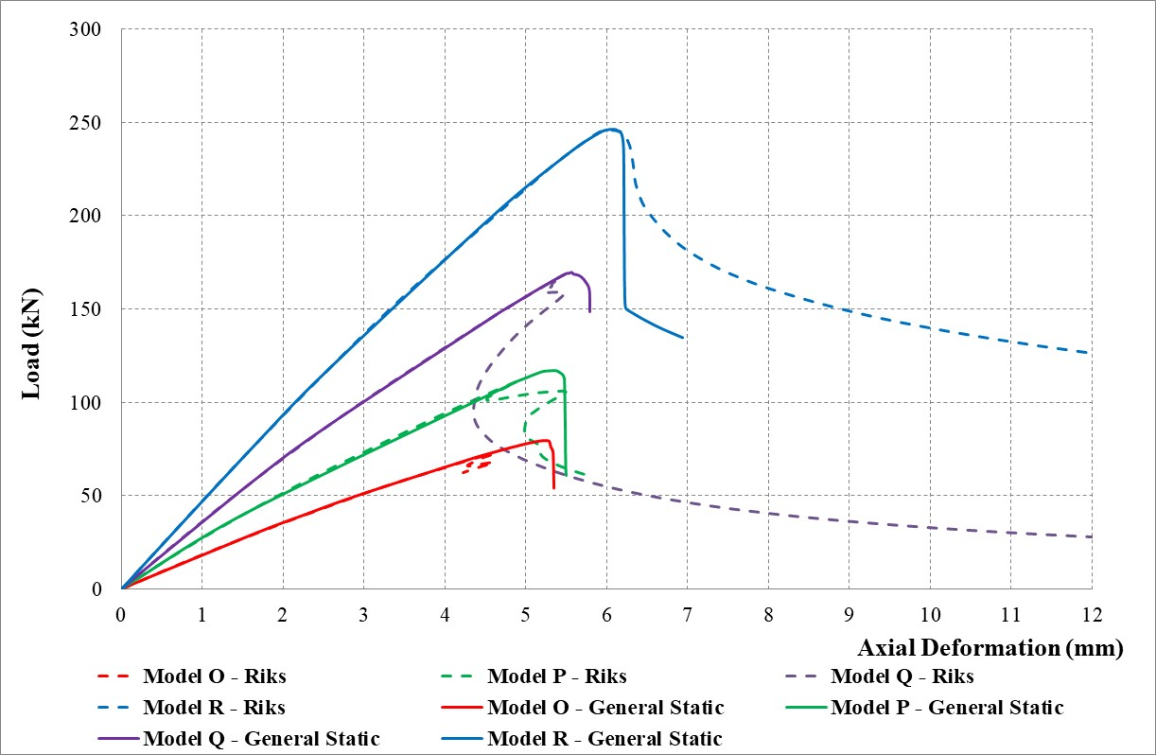

1. 100 C-Purlin studs
2. 150 C-Purlin studs

**Model K**

**Model L**

**Model M**

**Model N**

**Model O**

**Model P**

**Model Q**

**Model R**

Figure 9: Load versus Axial Deformation Curves from Finite Element Analyses

Table 3: Buckling Loads of Wall Studs Lined with Gypsum Plasterboards

|  |  |  |  |  |  |  |
| --- | --- | --- | --- | --- | --- | --- |
| Stud FE Model No | LSF Wall Panels | | | Wall Stud Buckling Analysis | | |
| Mode | Load (kN) | |
| Stud Size  (External Dimensions) | Stud Thickness (mm) | Grade | From CUFSM | From Abaqus CAE |
| Model A | 75x35x8 Lipped Channel Stud | 0.55 | G550 | Local | 4.81 | 4.75 |
| Model B | 0.75 | G550 | Local | 12.38 | 12.00 |
| Model C | 1.00 | G550 | Local | 28.50 | 28.34 |
| Model D | 1.20 | G500 | Global | 37.49 | 37.05 |
| Model E | 1.60 | G450 | Global | 48.98 | 48.35 |
| Model F | 90x35x8 Lipped Channel Stud | 0.55 | G550 | Local | 3.68 | 3.65 |
| Model G | 0.75 | G550 | Local | 9.28 | 9.24 |
| Model H | 1.00 | G550 | Local | 21.76 | 21.82 |
| Model I | 1.20 | G500 | Local | 38.01 | 37.52 |
| Model J | 1.60 | G450 | Global | 74.49 | 73.74 |
| Model K | 100 C-Purlin  (102x51x12.5 mm) | 1.00 | G550 | Local | 22.75 | 21.70 |
| Model L | 1.20 | G500 | Local | 37.67 | 37.45 |
| Model M | 100 C-Purlin  (102x51x13.5 mm) | 1.50 | G450 | Local | 74.42 | 73.66 |
| Model N | 100 C-Purlin  (102x51x14.5 mm) | 1.90 | G450 | Global | 154.18 | 150.45 |
| Model O | 150 C-Purlin  (152x64x14.5 mm) | 1.20 | G500 | Local | 23.73 | 23.23 |
| Model P | 150 C-Purlin  (152x64x15.5 mm) | 1.50 | G450 | Local | 45.29 | 45.41 |
| Model Q | 150 C-Purlin  (152x64x16.5 mm) | 1.90 | G450 | Local | 94.00 | 92.86 |
| Model R | 150 C-Purlin  (152x64x18.5 mm) | 2.40 | G450 | Local | 192.56 | 188.49 |

|  |  |  |  |  |  |  |
| --- | --- | --- | --- | --- | --- | --- |
| Stud FE Model No | LSF Wall Panels | | | Ultimate Axial Compression Capacity (kN) | | |
| Stud Size  (External Dimensions) | Stud Thickness (mm) | Grade | Mode | Riks-ON Method | General Static Analysis |
| Model A | 75x35x8 Lipped Channel Stud | 0.55 | G550 | Local | -# | 15.97 |
| Model B | 0.75 | G550 | Local | 29.64 | 29.65 |
| Model C | 1.00 | G550 | Local | 45.50 | 46.83 |
| Model D | 1.20 | G500 | Local + Global | -# | 57.65 |
| Model E | 1.60 | G450 | Global | -# | 78.27 |
| Model F | 90x35x8 Lipped Channel Stud | 0.55 | G550 | Local | 15.95 | 16.13 |
| Model G | 0.75 | G550 | Local | -# | 29.51 |
| Model H | 1.00 | G550 | Local | 44.10 | 44.45 |
| Model I | 1.20 | G500 | Local + Global | 59.82 | 61.85 |
| Model J | 1.60 | G450 | Local + Global | -# | 70.69 |
| Model K | 100 C-Purlin  (102x51x12.5 mm) | 1.00 | G550 | Local | 53.87 | 54.41 |
| Model L | 1.20 | G500 | Local | 74.18 | 75.12 |
| Model M | 100 C-Purlin  (102x51x13.5 mm) | 1.50 | G450 | Local | -# | 107.96 |
| Model N | 100 C-Purlin  (102x51x14.5 mm) | 1.90 | G450 | Local + Global | 146.33 | 147.82 |
| Model O | 150 C-Purlin  (152x64x14.5 mm) | 1.20 | G500 | Local | 78.55 | 79.36 |
| Model P | 150 C-Purlin  (152x64x15.5 mm) | 1.50 | G450 | Local | 116.35 | 117.17 |
| Model Q | 150 C-Purlin  (152x64x16.5 mm) | 1.90 | G450 | Local | 168.58 | 169.77 |
| Model R | 150 C-Purlin  (152x64x18.5 mm) | 2.40 | G450 | Local | 245.82 | 246.34 |

Table 4: Ultimate Axial Compression Capacities of Wall Studs Lined with Gypsum Plasterboards

Note: #- Riks FE analysis did not converge, thus unable to predict the ultimate failure load (no

unloading).

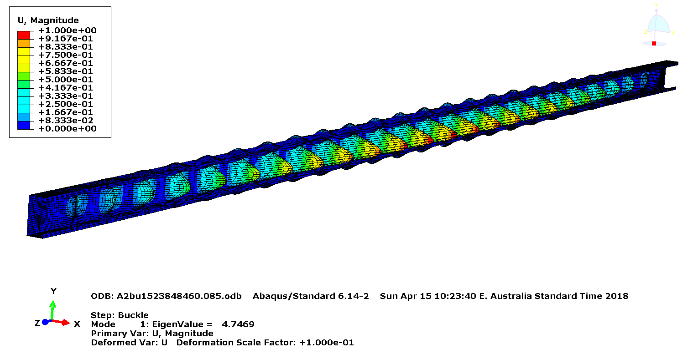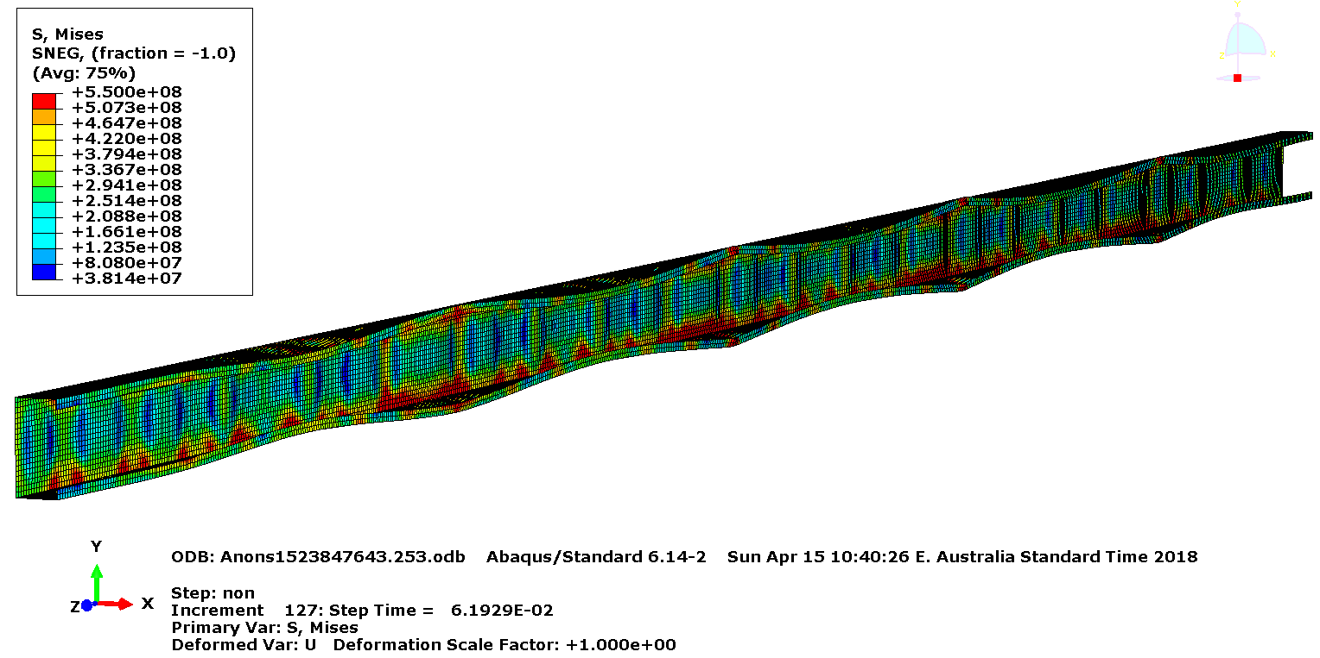

1. Bifurcation buckling analysis – Lowest mode (Mode 1)
2. Non-linear analysis – at failure

**Buckling load = 4.75 kN**

**Ultimate Axial Compression Load = 15.97 kN**

**Figure 10: Finite Element Analyses of 75×35×8×0.55 mm G550 Lipped Channel Stud –**

**Model A**

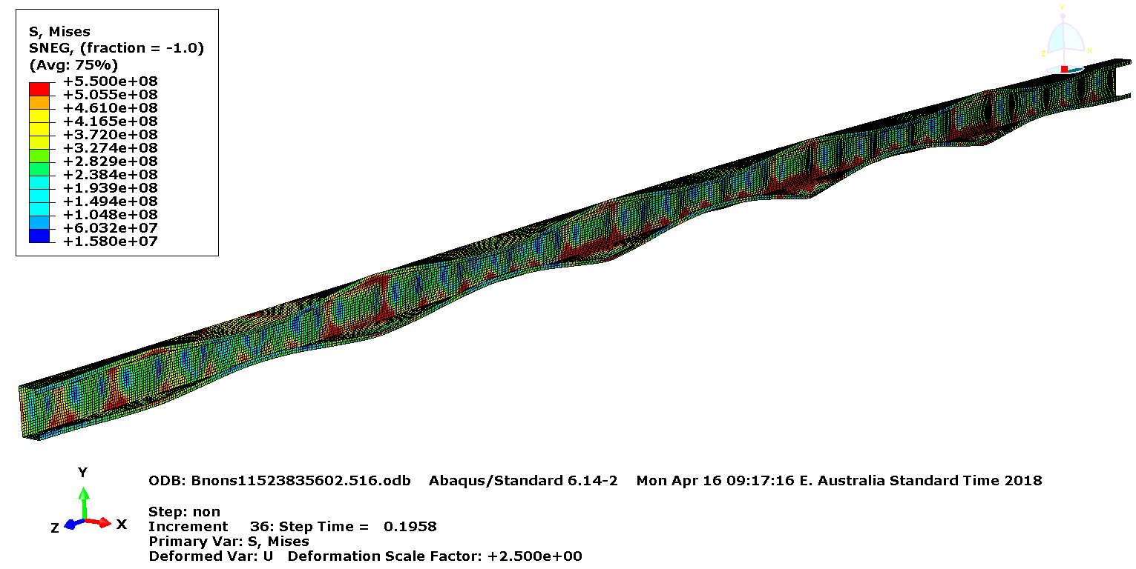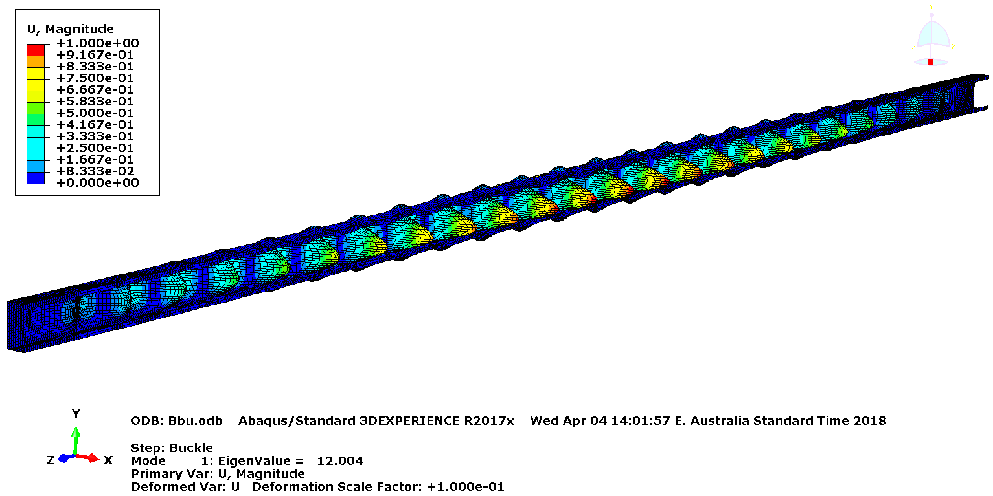

1. Bifurcation buckling analysis – Lowest mode (Mode 1)
2. Non-linear analysis – at failure

**Buckling load = 12.00 kN**

**Ultimate Axial Compression Load = 29.65 kN**

**Figure 11: Finite Element Analyses of 75×35×8×0.75 mm G550 Lipped Channel Stud –**

**Model B**

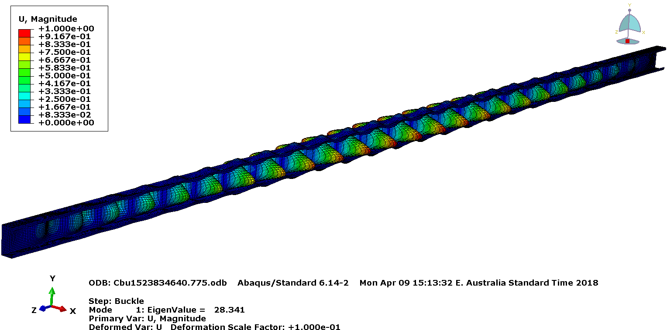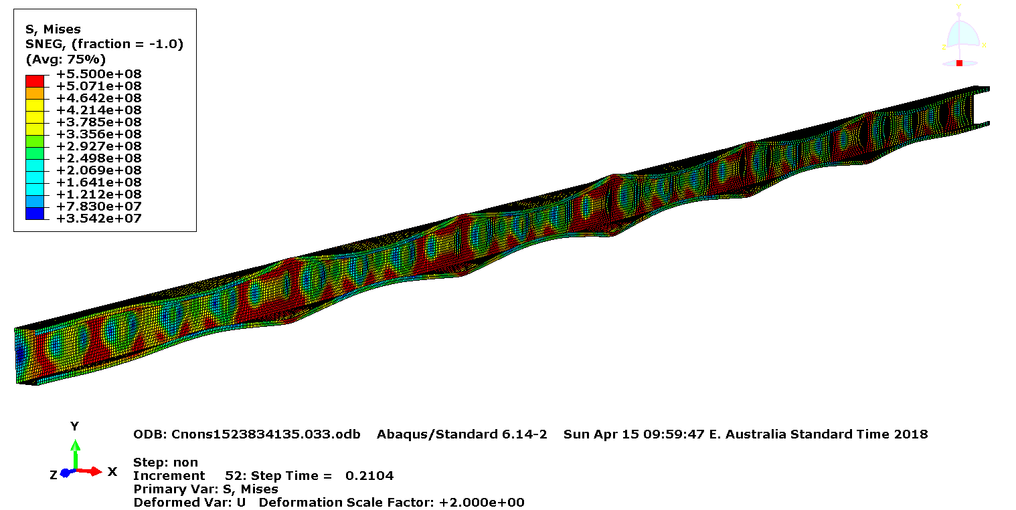

1. Bifurcation buckling analysis – Lowest mode (Mode 1)
2. Non-linear analysis – at failure

**Buckling load = 28.34 kN**

**Ultimate Axial Compression Load = 46.83 kN**

**Figure 12: Finite Element Analyses of 75×35×8×1.00 mm G550 Lipped Channel Stud –**

**Model C**

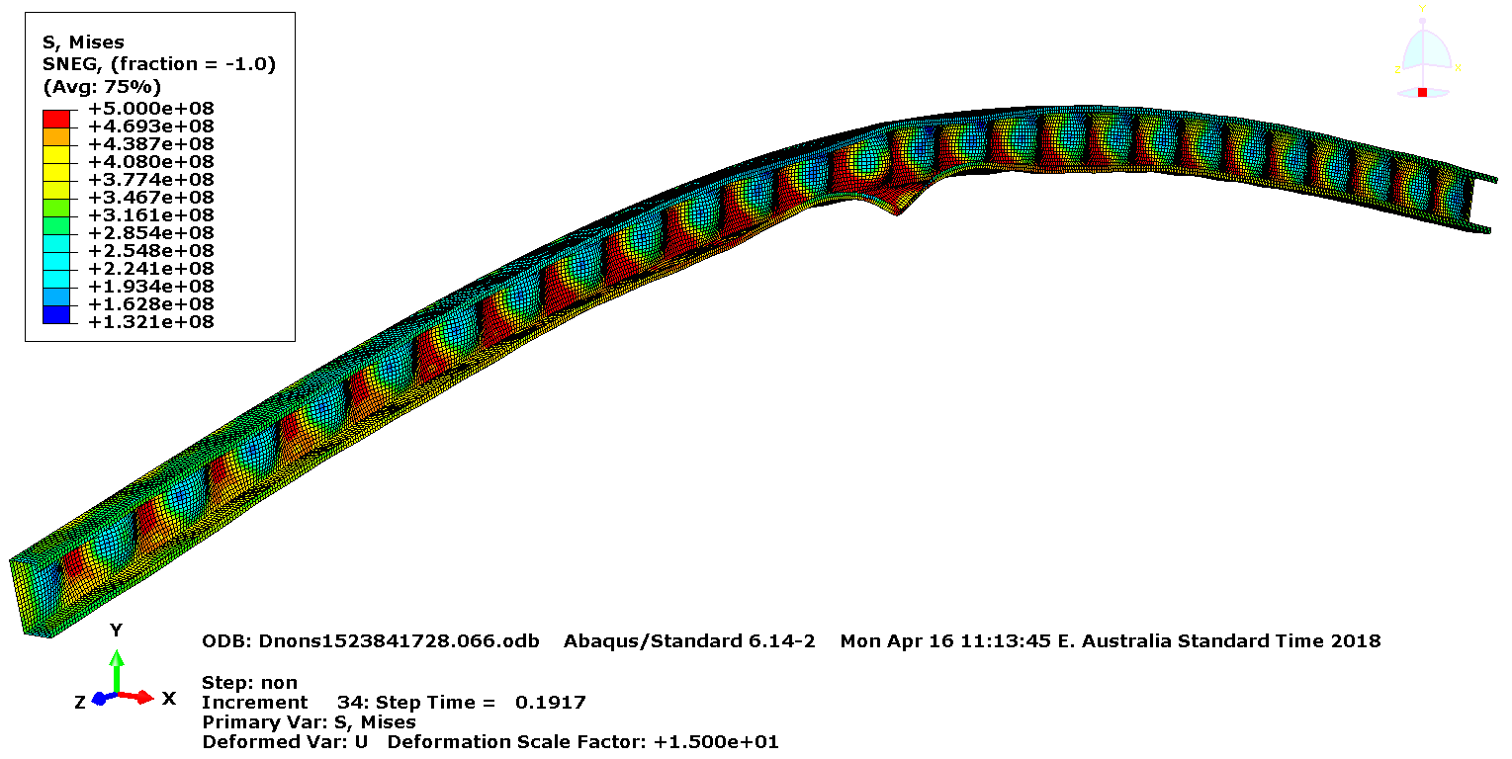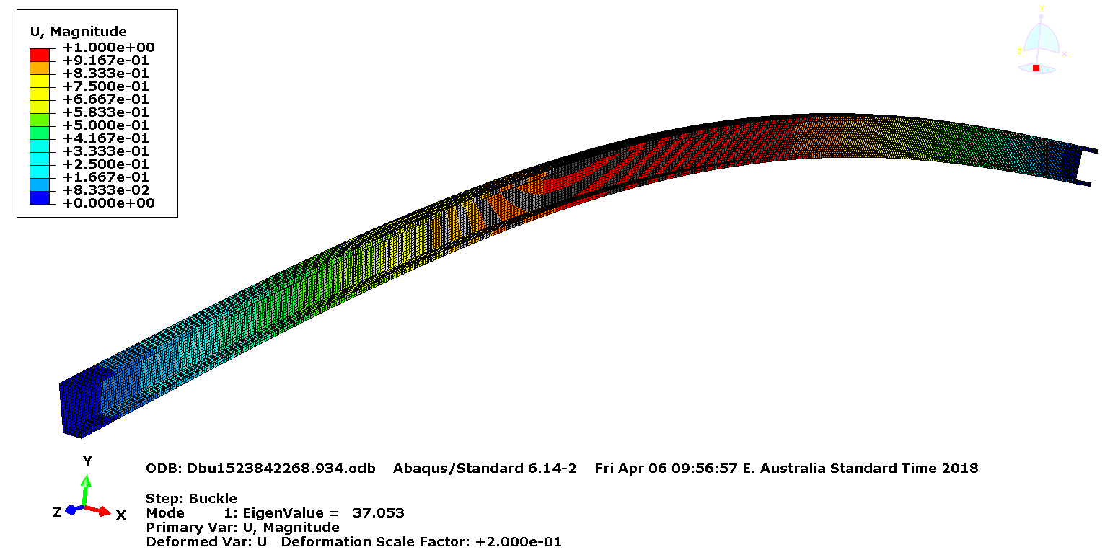

1. Bifurcation buckling analysis – Lowest mode (Mode 1)
2. Non-linear analysis – at failure

**Buckling load = 37.05 kN**

**Ultimate Axial Compression Load = 57.65 kN**

**Figure 13: Finite Element Analyses of 75×35×8×1.20 mm G500 Lipped Channel Stud –**

**Model D**

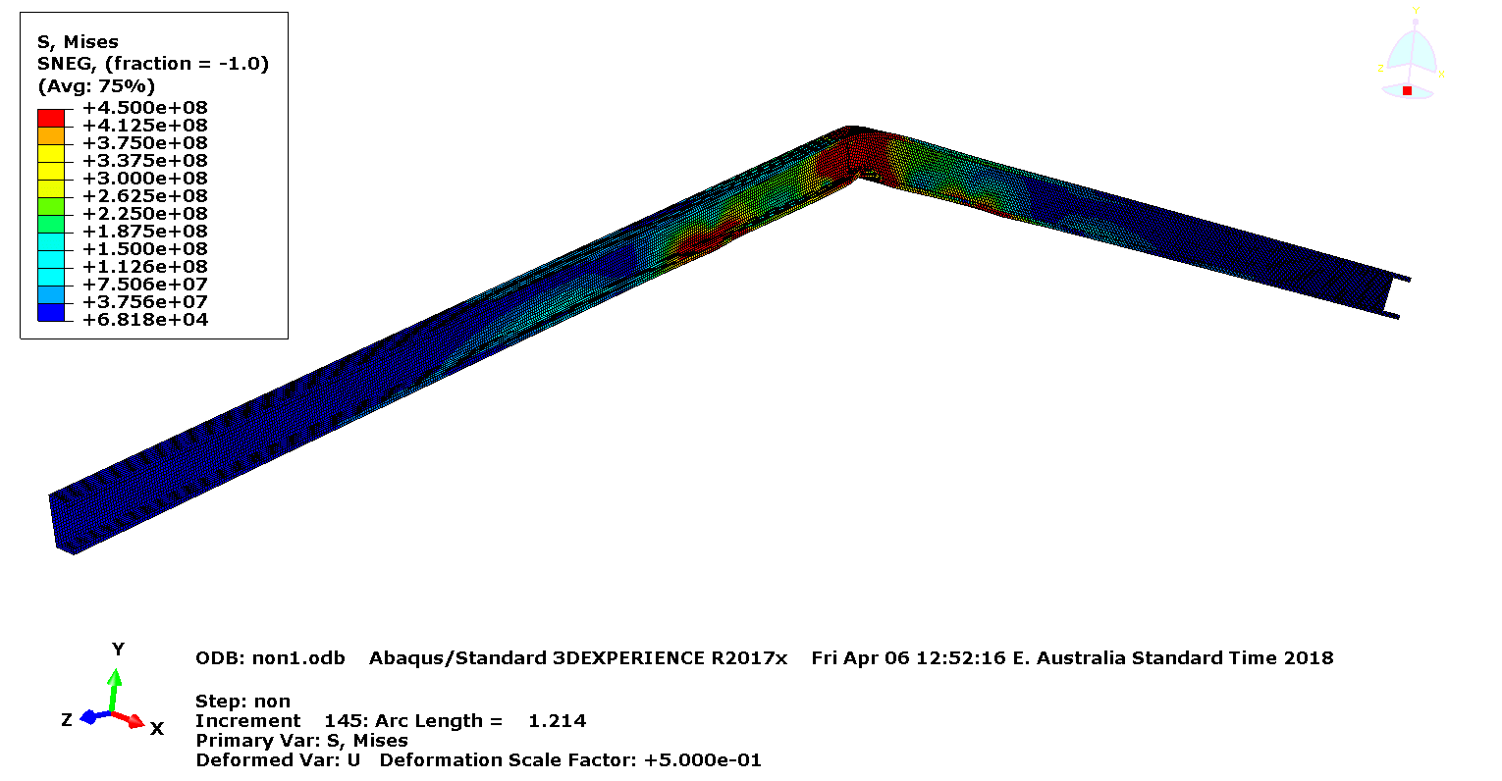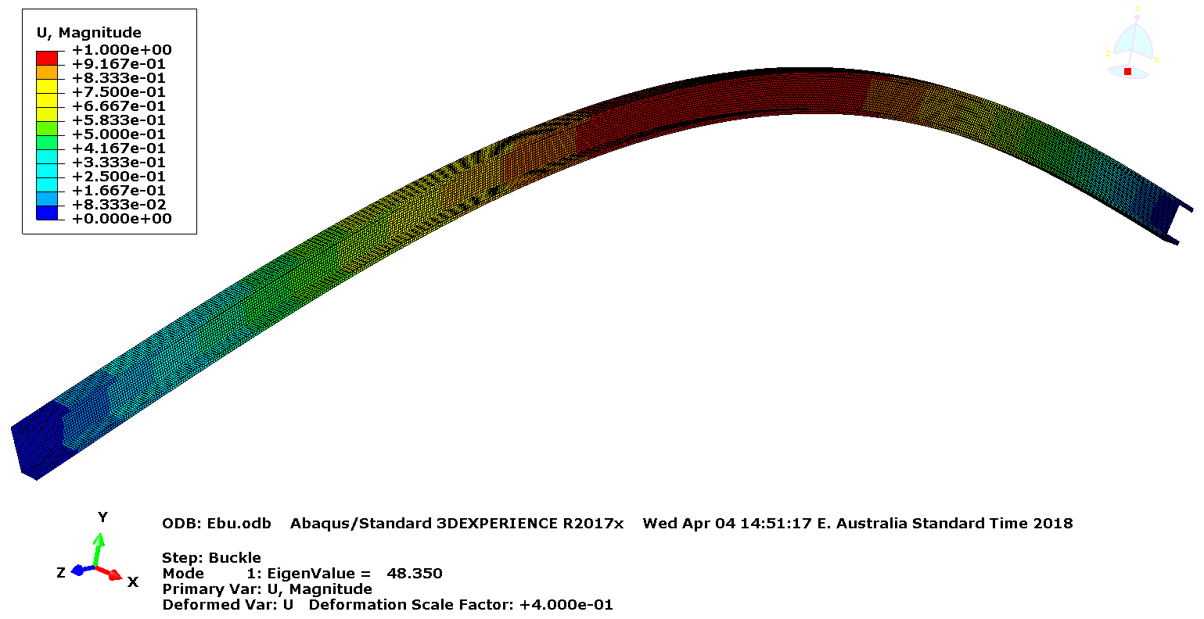

1. Bifurcation buckling analysis – Lowest mode (Mode 1)
2. Non-linear analysis – at failure

**Buckling load = 48.35 kN**

**Ultimate Axial Compression Load = 78.27 kN**

**Figure 14: Finite Element Analyses of 75×35×8×1.60 mm G450 Lipped Channel Stud –**

**Model E**

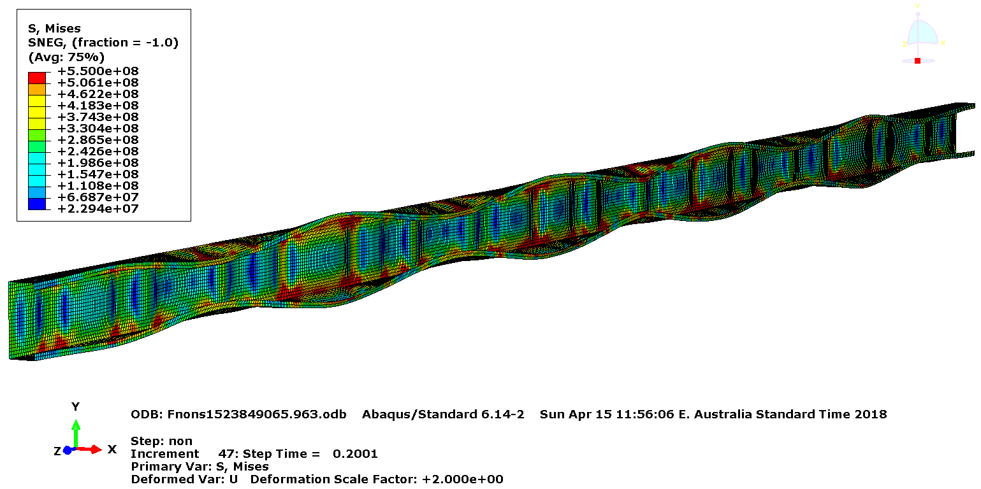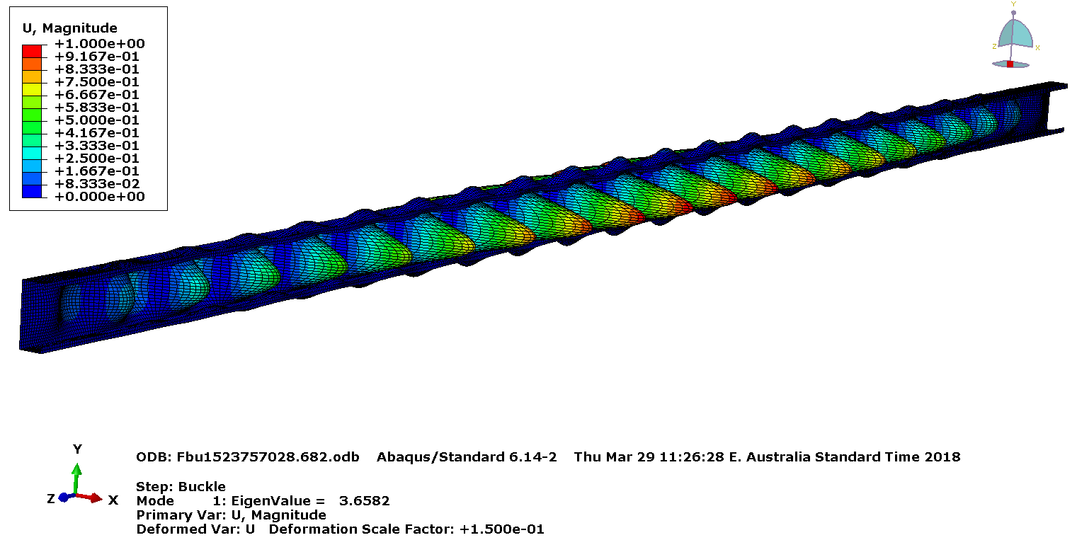

1. Bifurcation buckling analysis – Lowest mode (Mode 1)
2. Non-linear analysis – at failure

**Buckling load = 3.65 kN**

**Ultimate Axial Compression Load = 16.13 kN**

**Figure 15: Finite Element Analyses of 90×35×8×0.55 mm G550 Lipped Channel Stud –**

**Model F**

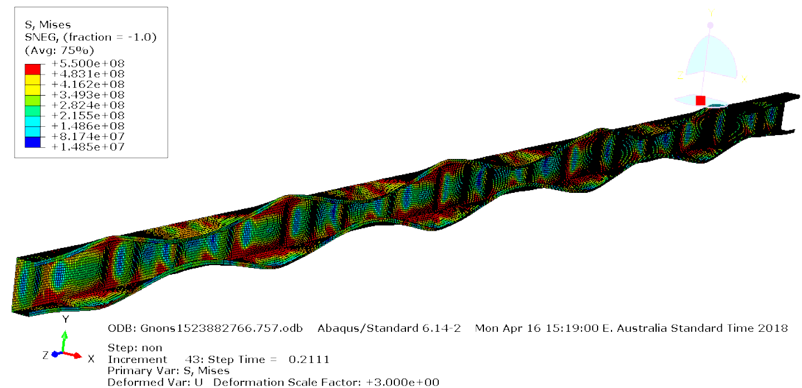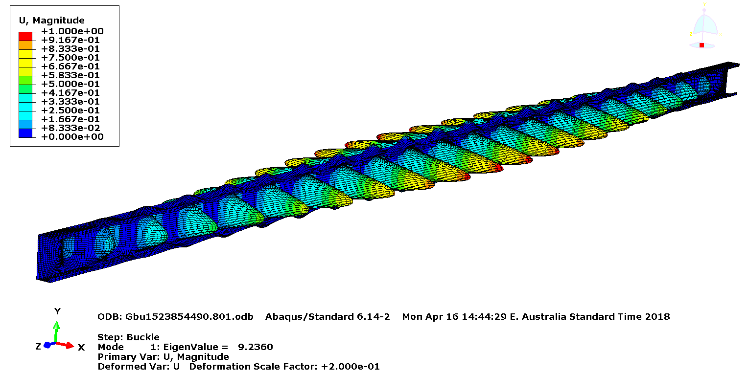

1. Bifurcation buckling analysis – Lowest mode (Mode 1)
2. Non-linear analysis – at failure

**Buckling load = 9.24 kN**

**Ultimate Axial Compression Load = 29.51 kN**

**Figure 16: Finite Element Analyses of 90×35×8×0.75 mm G550 Lipped Channel Stud –**

**Model G**

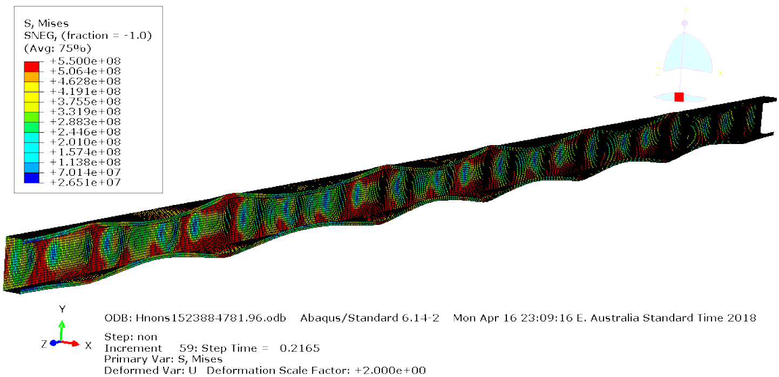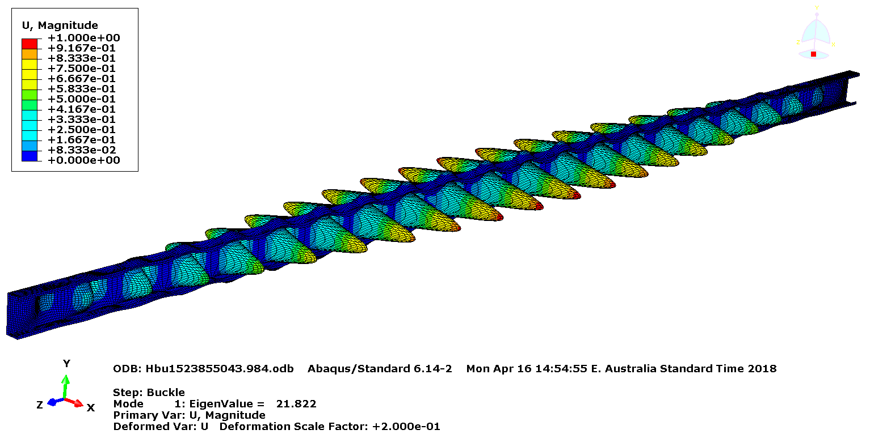

1. Bifurcation buckling analysis – Lowest mode (Mode 1)
2. Non-linear analysis – at failure

**Buckling load = 21.82 kN**

**Ultimate Axial Compression Load = 44.45 kN**

**Figure 17: Finite Element Analyses of 90×35×8×1.00 mm G550 Lipped Channel Stud –**

**Model H**

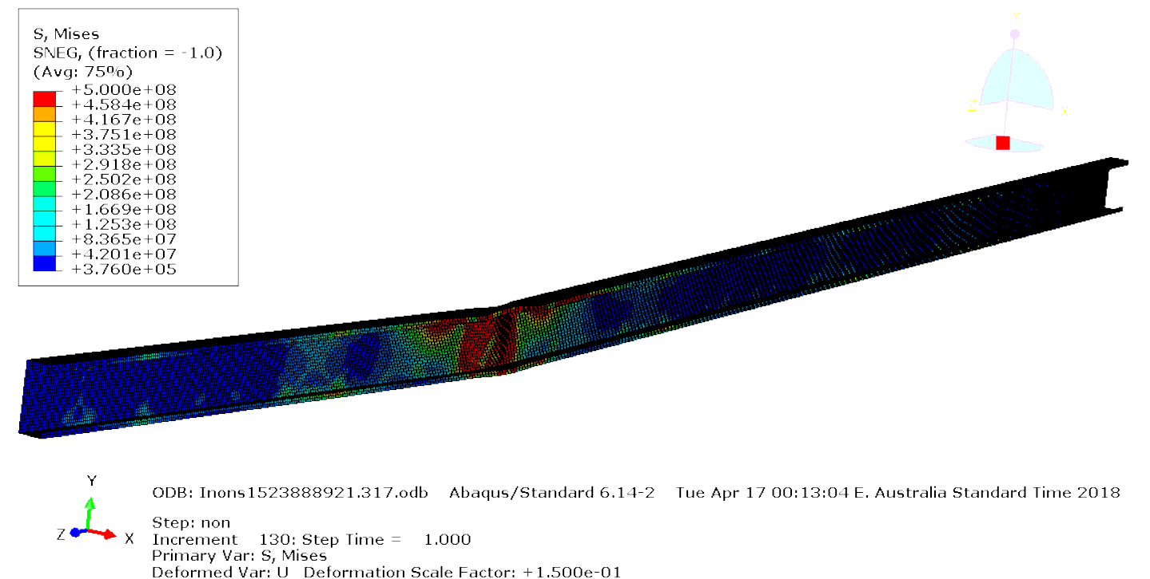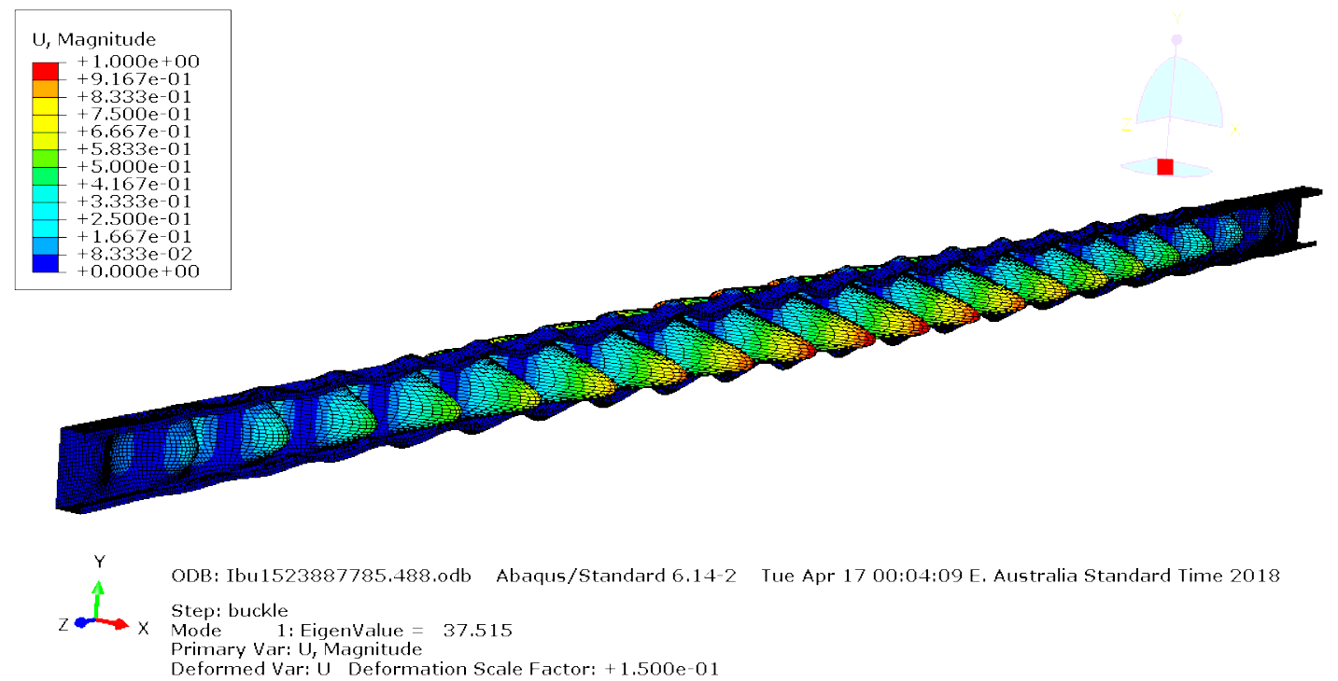

1. Bifurcation buckling analysis – Lowest mode (Mode 1)
2. Non-linear analysis – at failure

**Buckling load = 37.52 kN**

**Ultimate Axial Compression Load = 61.85 kN**

**Figure 18: Finite Element Analyses of 90×35×8×1.20 mm G500 Lipped Channel Stud –**

**Model I**

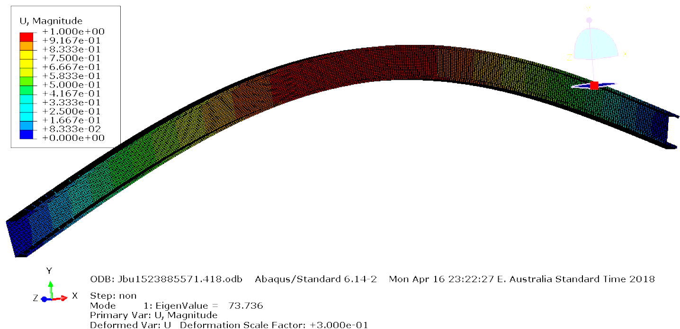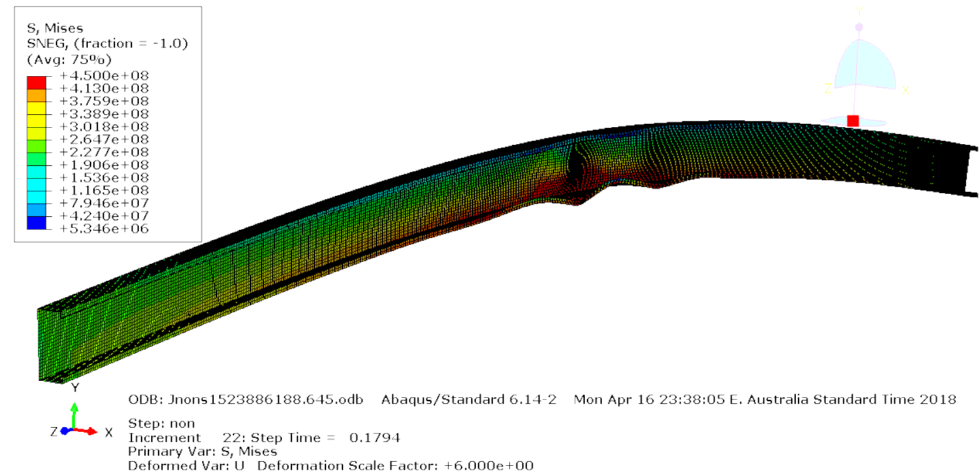

1. Bifurcation buckling analysis – Lowest mode (Mode 1)
2. Non-linear analysis – at failure

**Buckling load = 73.74 kN**

**Ultimate Axial Compression Load = 70.69 kN**

**Figure 19: Finite Element Analyses of 90×35×8×1.60 mm G450 Lipped Channel Stud –**

**Model J**

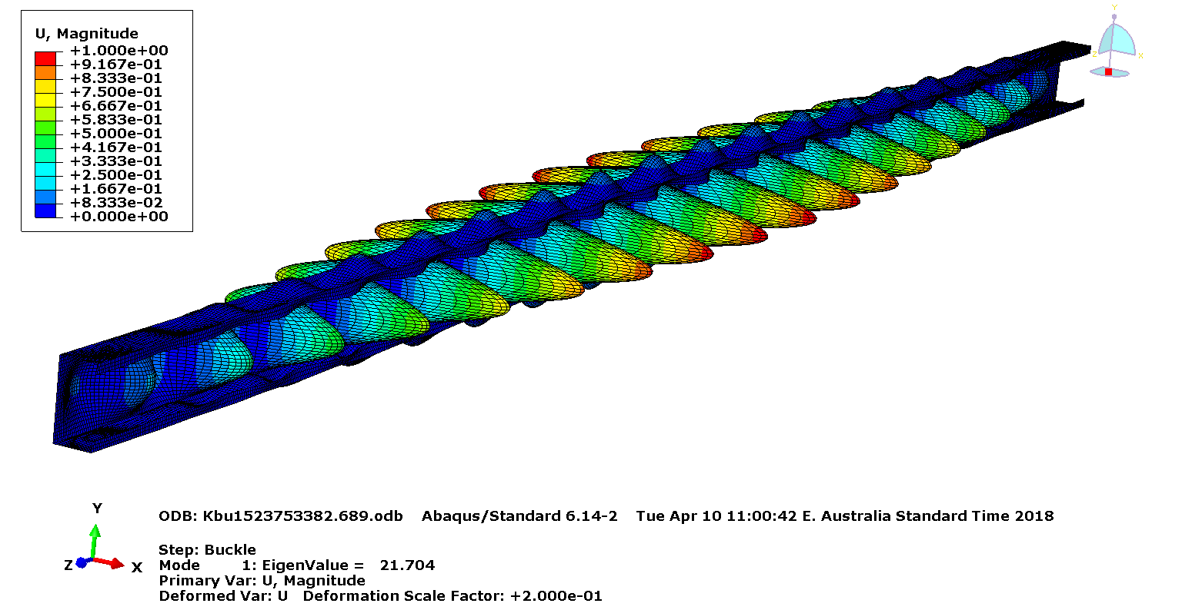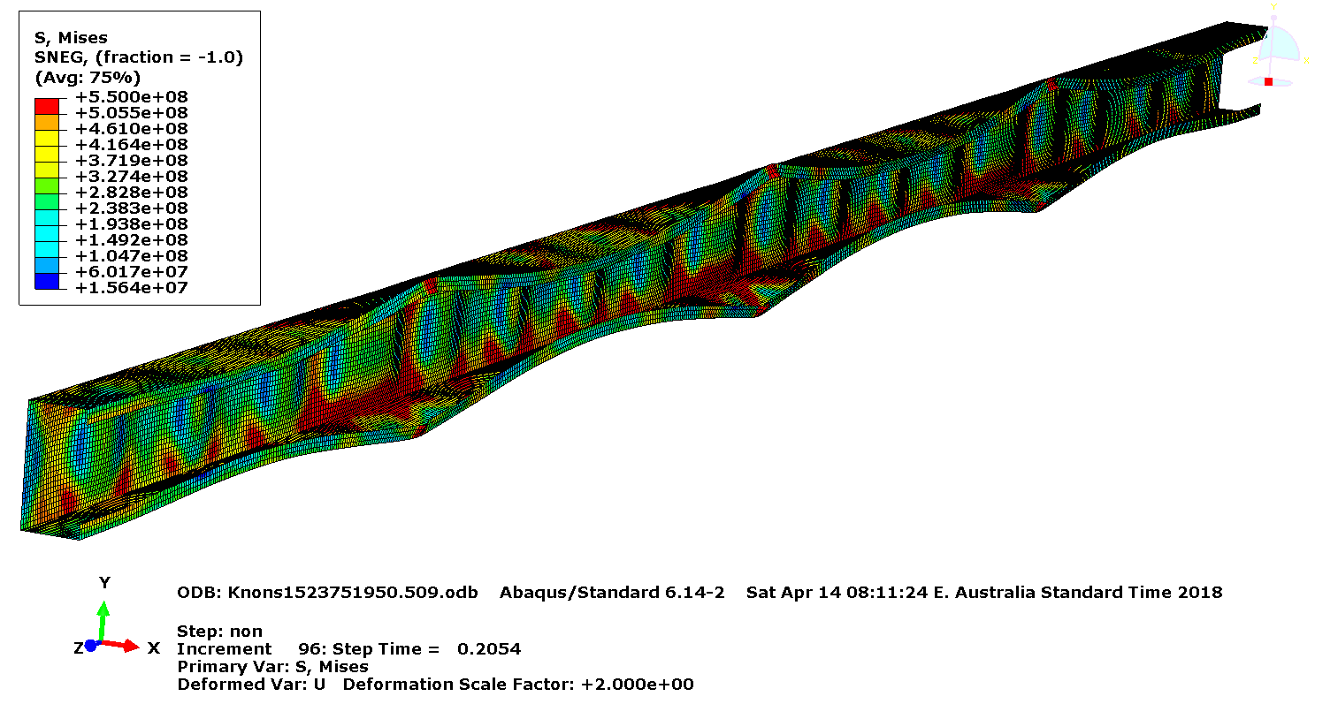

1. Bifurcation buckling analysis – Lowest mode (Mode 1)
2. Non-linear analysis – at failure

**Buckling load = 21.70 kN**

**Ultimate Axial Compression Load = 54.41 kN**

**Figure 20: Finite Element Analyses of 102x51x12.5x1.00 mm G550 C-Purlin – Model K**

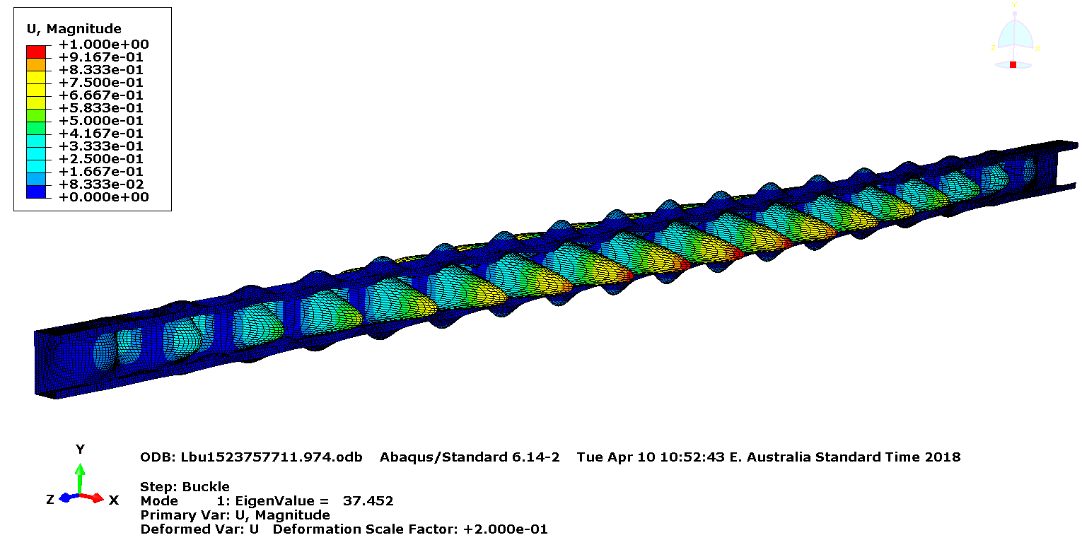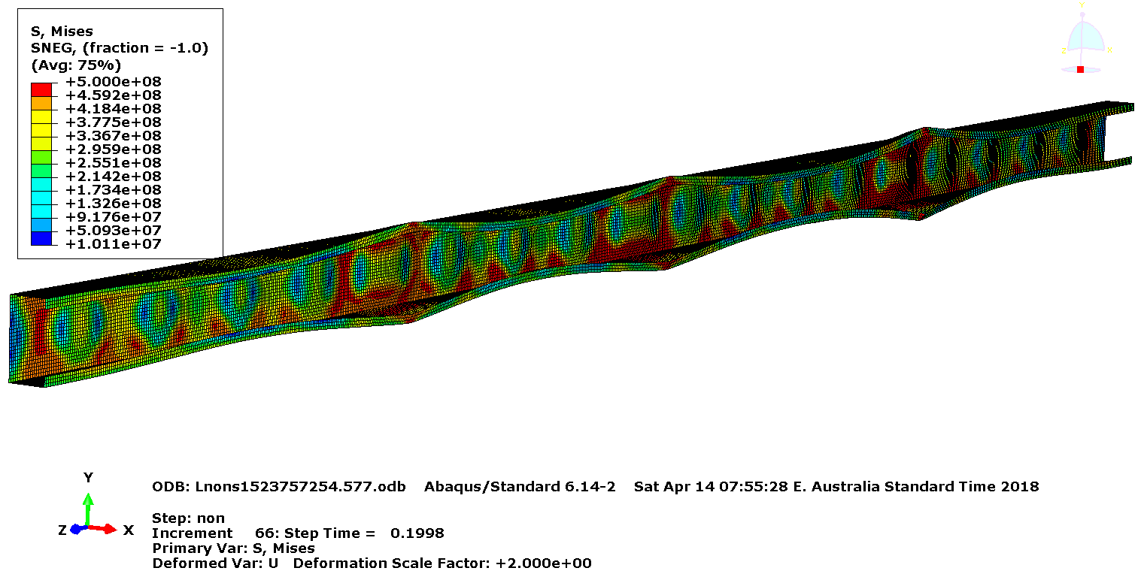

1. Bifurcation buckling analysis – Lowest mode (Mode 1)
2. Non-linear analysis – at failure

**Buckling load = 37.45 kN**

**Ultimate Axial Compression Load = 75.12 kN**

**Figure 21: Finite Element Analyses of 102x51x12.5x1.20 mm G500 C-Purlin – Model L**

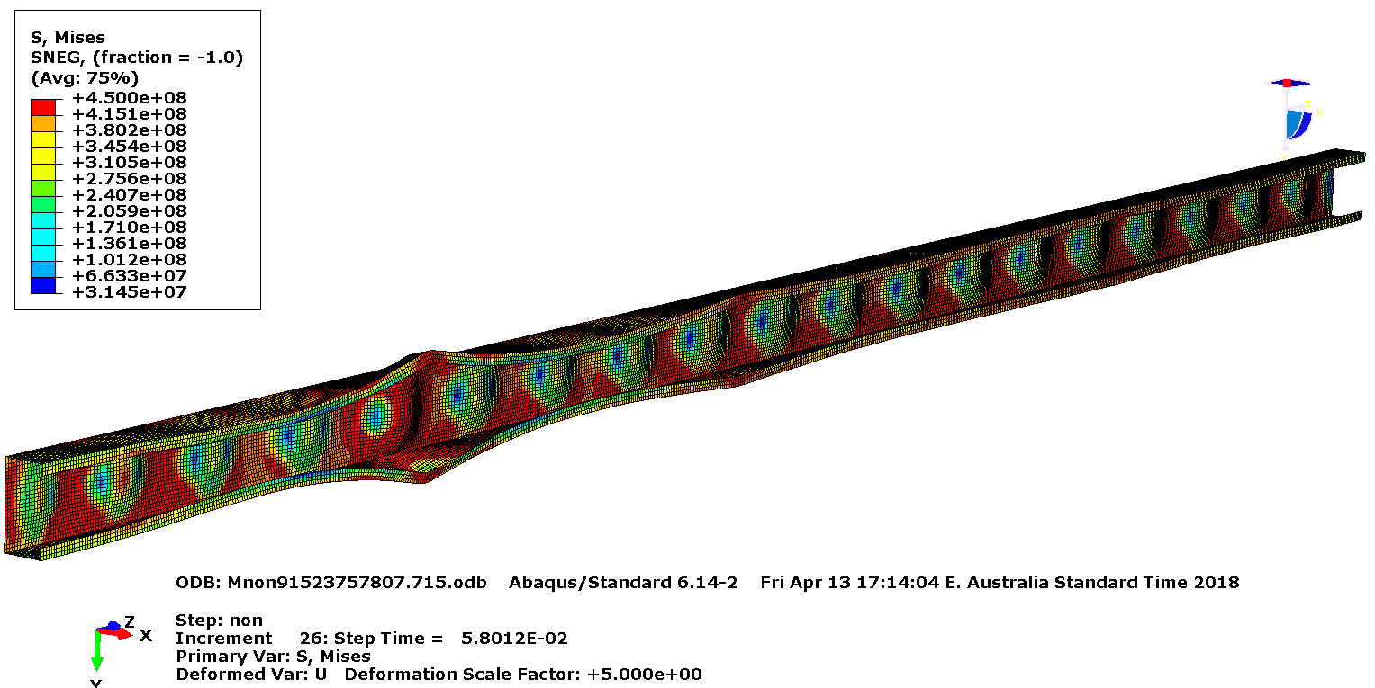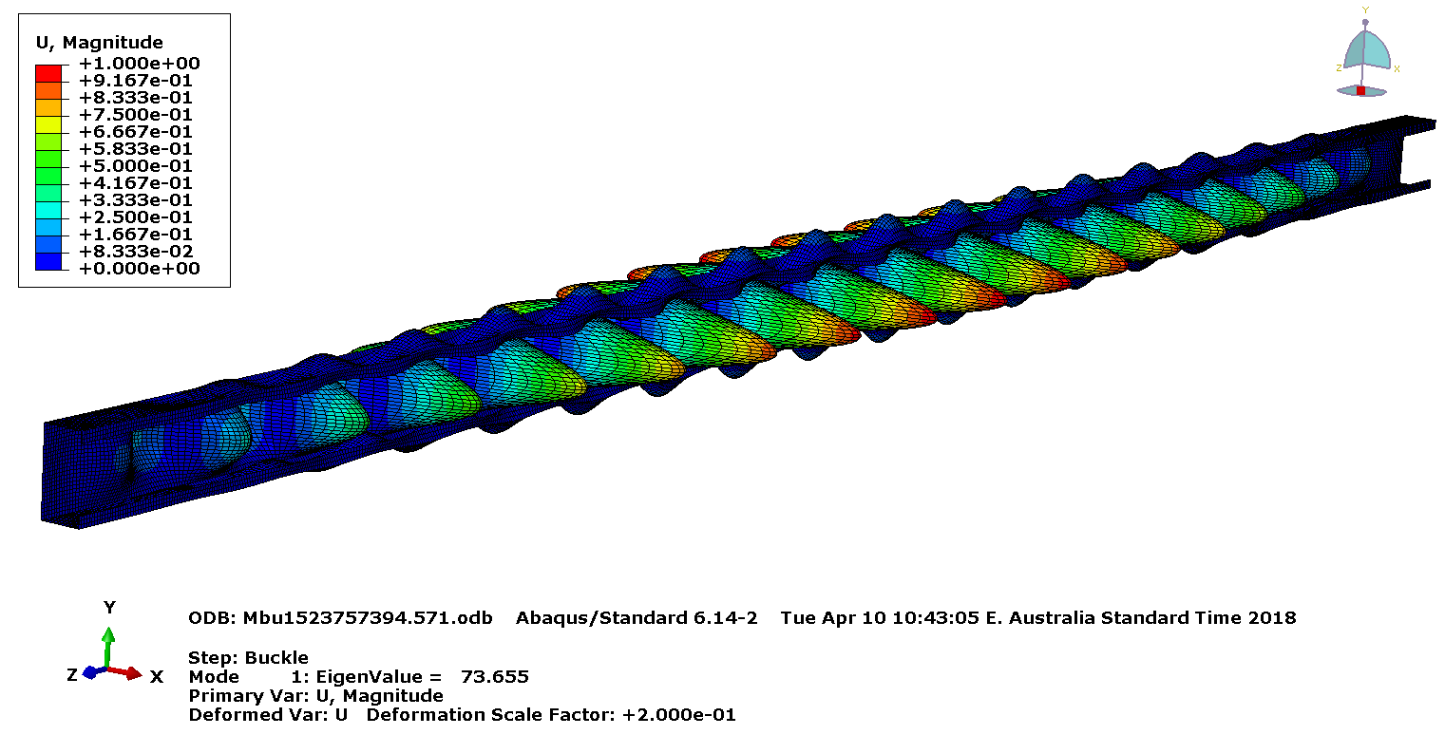

1. Bifurcation buckling analysis – Lowest mode (Mode 1)
2. Non-linear analysis – at failure

**Buckling load = 73.66 kN**

**Ultimate Axial Compression Load = 107.96 kN**

**Figure 22: Finite Element Analyses of 102x51x13.5x1.50 mm G450 C-Purlin – Model M**

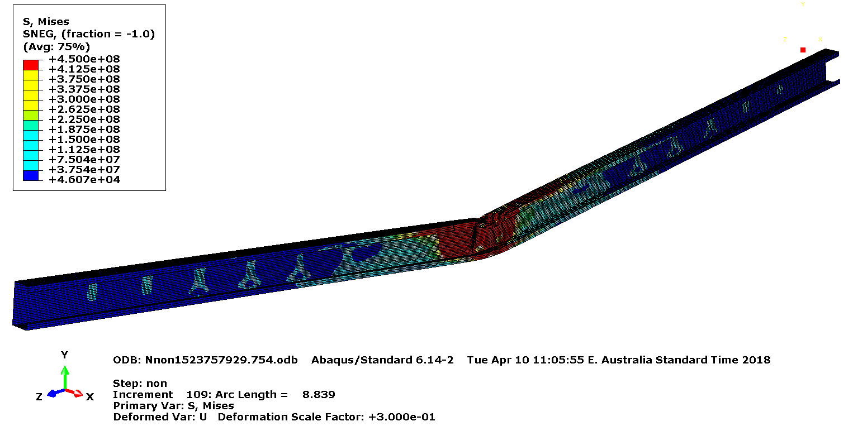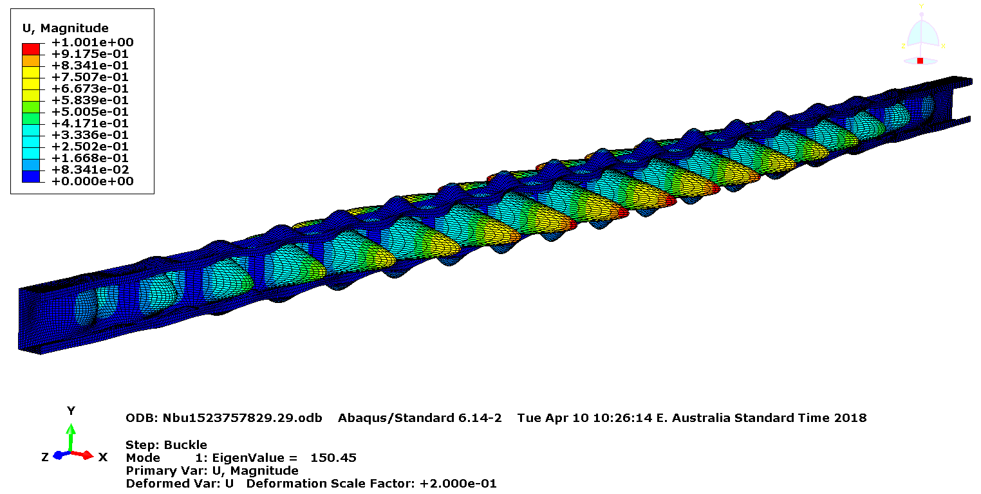

1. Bifurcation buckling analysis – Lowest mode (Mode 1)
2. Non-linear analysis – at failure

**Buckling load = 150.45 kN**

**Ultimate Axial Compression Load = 146.33 kN**

**Figure 23: Finite Element Analyses of 102x51x14.5x1.90 mm G450 C-Purlin – Model N**

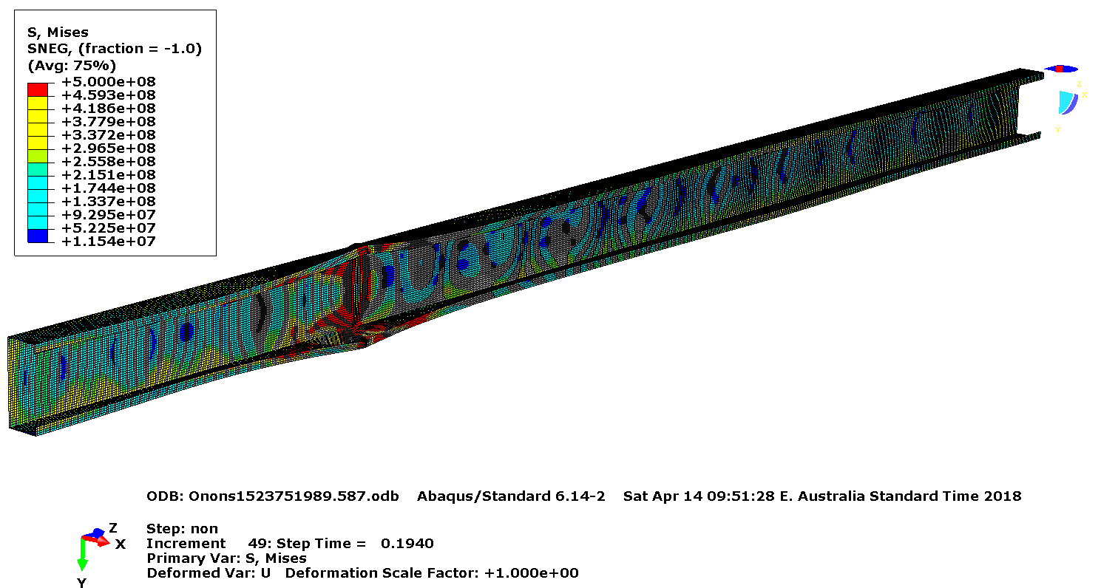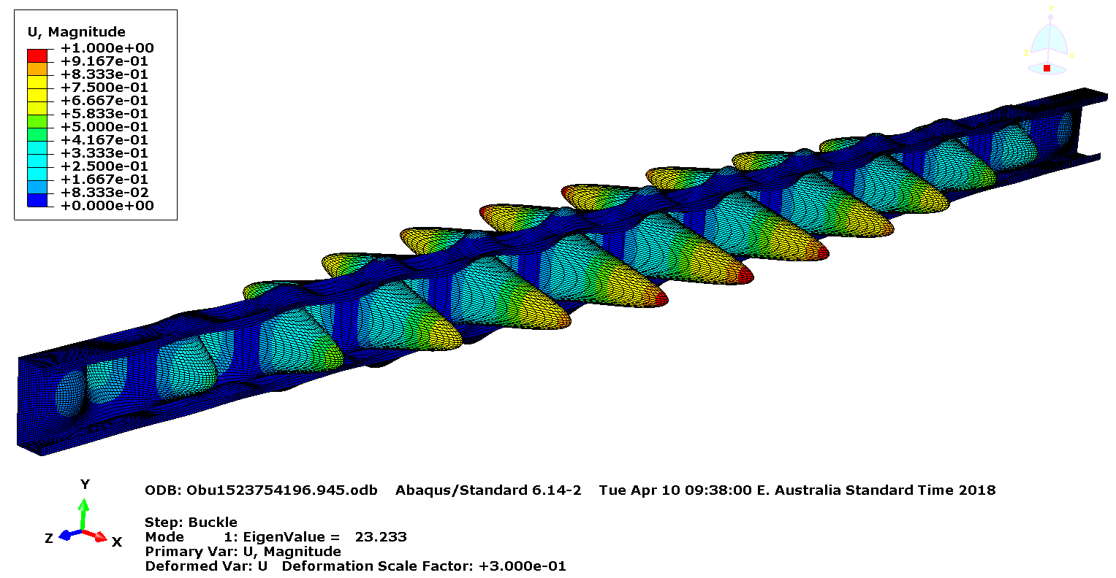

1. Bifurcation buckling analysis – Lowest mode (Mode 1)
2. Non-linear analysis – at failure

**Buckling load = 23.23 kN**

**Ultimate Axial Compression Load = 79.36 kN**

**Figure 24: Finite Element Analyses of 152x64x14.5x1.20 mm G500 C-Purlin – Model O**

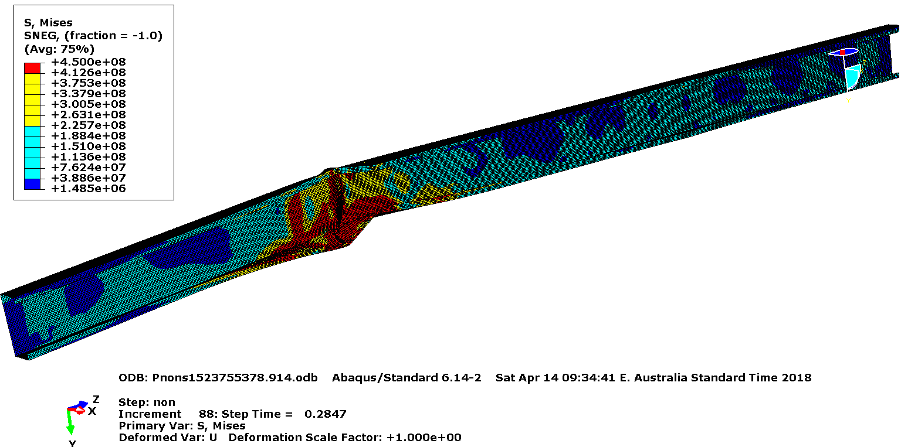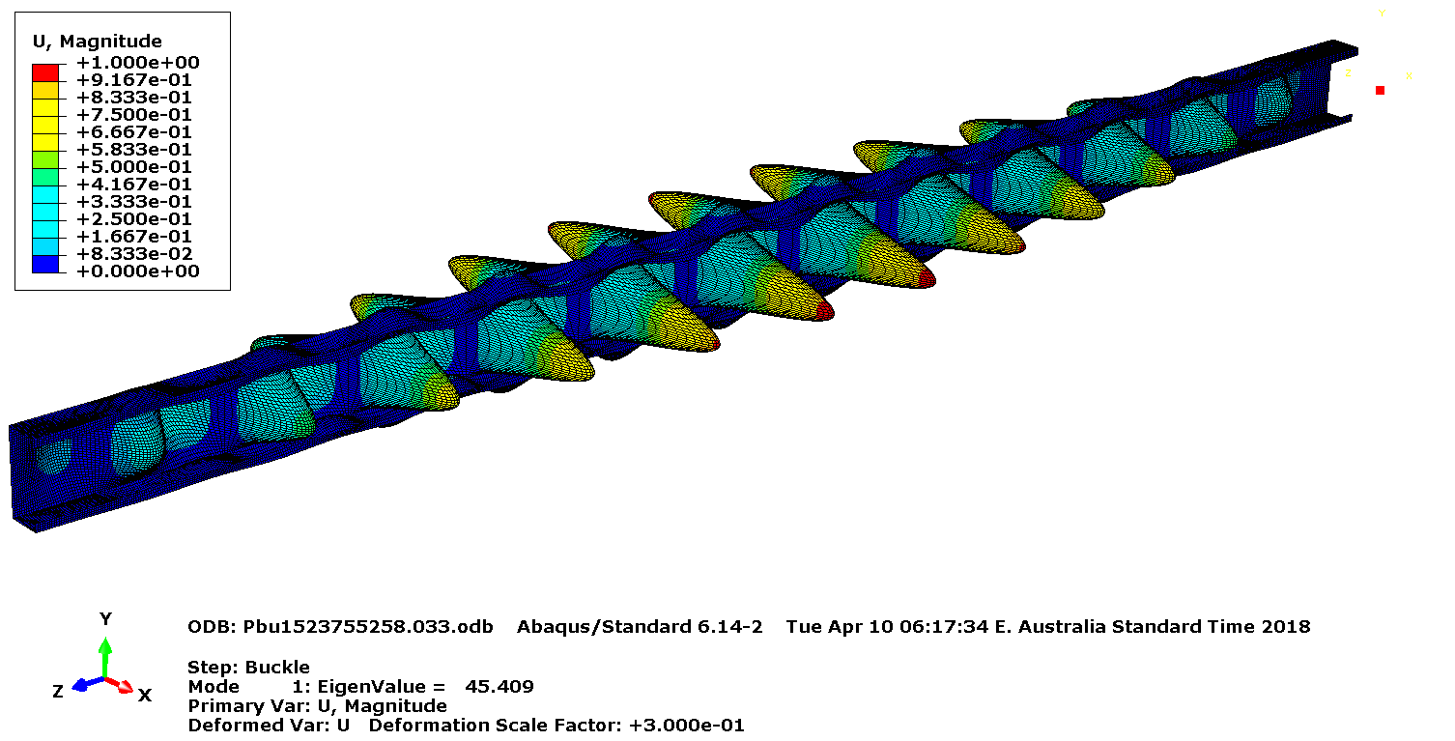

1. Bifurcation buckling analysis – Lowest mode (Mode 1)
2. Non-linear analysis – at failure

**Buckling load = 45.41 kN**

**Ultimate Axial Compression Load = 117.17 kN**

**Figure 25: Finite Element Analyses of 152x64x15.5x1.50 mm G450 C-Purlin – Model P**

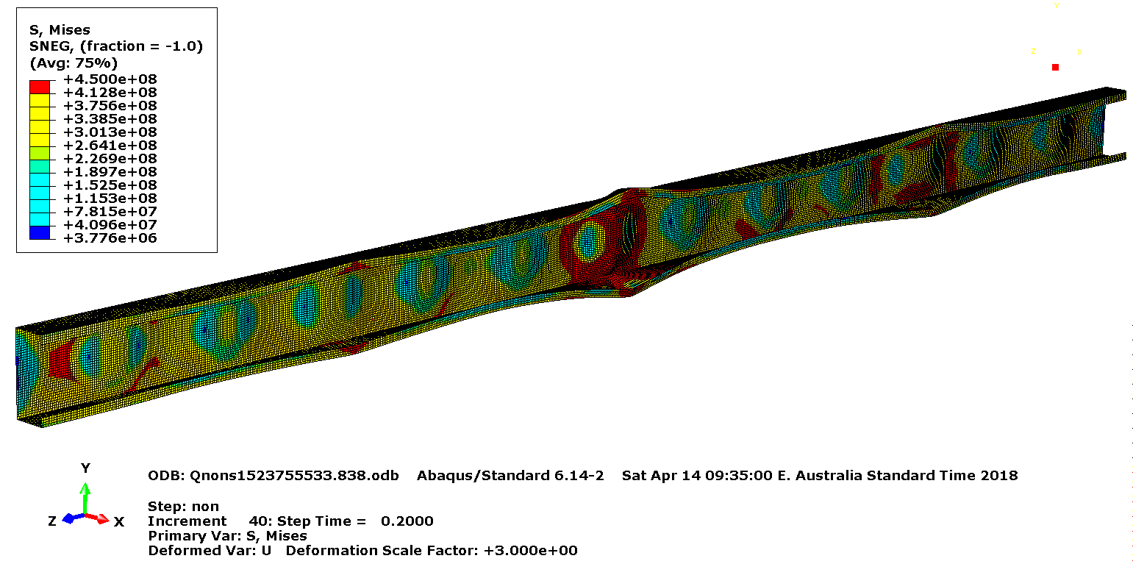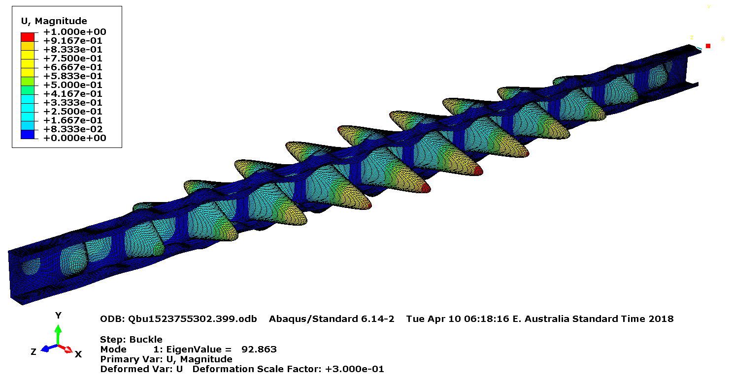

1. Bifurcation buckling analysis – Lowest mode (Mode 1)
2. Non-linear analysis – at failure

**Buckling load = 92.86 kN**

**Ultimate Axial Compression Load = 169.77 kN**

**Figure 26: Finite Element Analyses of 152x64x16.5x1.90 mm G450 C-Purlin – Model Q**

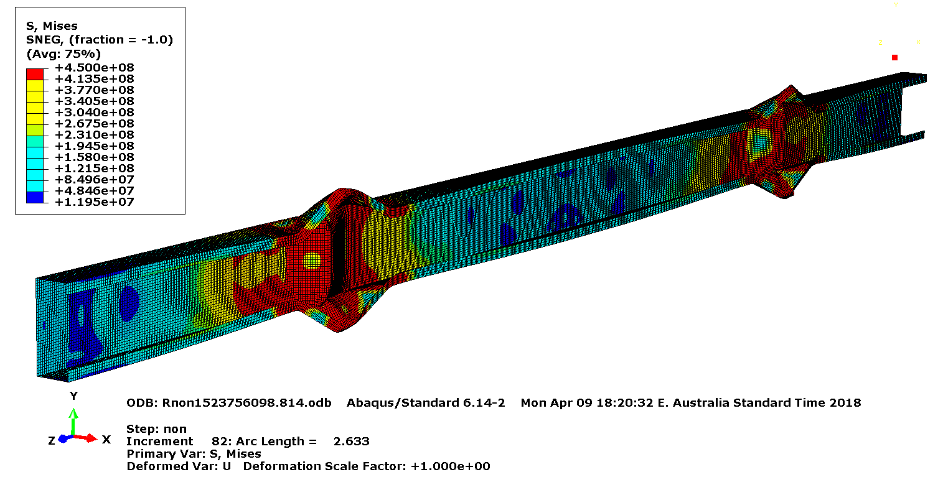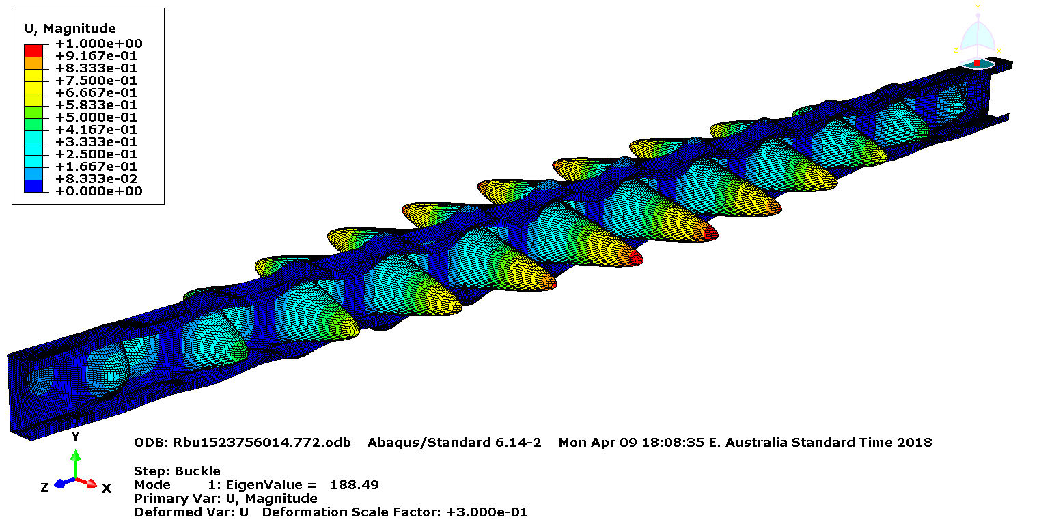

1. Bifurcation buckling analysis – Lowest mode (Mode 1)
2. Non-linear analysis – at failure

**Buckling load = 188.49 kN**

**Ultimate Axial Compression Load = 245.82 kN**

**Figure 27: Finite Element Analyses of 152x64x18.5x2.40 mm G450 C-Purlin – Model R**

# Design of Stud Walls at Ambient Temperature

Direct Strength Method (DSM) in AS/NZS 4600 (SA, 2005) was used to determine the ambient temperature axial compression capacities of stud walls lined with gypsum plasterboards (Eqs. 1 to 9). Similar to the FE analyses, nominal mechanical properties shown in Table 1 were used in the design calculations. The DSM requires elastic buckling loads to calculate the ultimate capacity of the studs, thus the buckling loads (Mode 1) obtained from the bifurcation buckling analyses in Abaqus CAE were used. Table 5 shows the axial compression capacities of wall studs obtained from DSM design rules and FE analyses.

1. Flexural buckling capacity (Nce)

For ${}_{c}≤1.5$ $N_{ce}=\left({0.658}^{{λ_{c}}^{2}}\right)N_{y}$ (1)

For ${}_{c}>1.5$ $N_{ce}=\left(\frac{0.877}{{λ_{c}}^{2}}\right)N_{y}$ (2)

where the slenderness for global buckling $λ_{c}=\sqrt{\frac{N_{y}}{N_{oc}}}$ (3)

*Ny* – Nominal yield load

*Noc* – Elastic flexural buckling load

1. Member capacity allowing for local and flexural buckling (Ncl,1)

For ${}_{l}≤0.776$ $N_{cl,1}=N_{ce}$ (4)

For ${}_{l}>0.776$ $N_{cl,1}=\left(1-0.15{\left(\frac{N_{ol}}{N_{ce}}\right)}^{0.4}\right){\left(\frac{N_{ol}}{N_{ce}}\right)}^{0.4}N_{ce}$ (5)

where the slenderness for local buckling $λ_{l}=\sqrt{\frac{N_{ce}}{N_{ol}}}$ (6)

*Nol* – Elastic local buckling load

1. Section capacity allowing for local buckling (Ncl,2)

For ${}_{l}≤0.776$ $N_{cl,2}=N_{ce}$ (7)

For ${}_{l}>0.776$ $N_{cl,2}=\left(1-0.15{\left(\frac{N_{ol}}{N_{y}}\right)}^{0.4}\right){\left(\frac{N_{ol}}{N_{y}}\right)}^{0.4}N_{y}$ (8)

where the slenderness for local buckling $λ_{l}=\sqrt{\frac{N_{y}}{N_{ol}}}$ (9)

*Nol* – Elastic local buckling load

Table 5: Comparison of FE Analysis Results with Predictions from DSM based Design Rules in AS/NZS 4600 for Type W1 LSF Wall Studs lined with Gypsum Plasterboards on Both Sides

|  |  |  |  |  |  |  |  |
| --- | --- | --- | --- | --- | --- | --- | --- |
| Stud FE Model No | LSF Wall Panels | | Ultimate Axial Compression Capacity (kN) | | | | |
| Stud Size  (External Dimensions) | Stud Thickness (mm) | DSM – Section capacity allowing for local buckling (Ncl,2) | DSM – allowing for Flexural buckling (Nce) | DSM – Member capacity allowing for local and flexural buckling (Ncl,1) | FE Analysis | Stud Failure Mode |
| Model A | 75x35x8 Lipped Channel Stud | 0.55 | 17.98 | 15.57 | 8.82 | 15.97 | Local |
| Model B | 0.75 | 30.95 | 21.00 | 14.93 | 29.65 | Local |
| Model C | 1.00 | 50.09 | 27.58 | 23.70 | 46.83 | Local |
| Model D | 1.20 | 64.24 | 32.76 | 31.84 | 57.65 | Local + Global |
| Model E | 1.60 | 96.14 | 42.70 | 42.70 | 78.27 | Global |
| Model F | 90x35x8 Lipped Channel Stud | 0.55 | 17.21 | 23.23 | 10.32 | 16.13 | Local |
| Model G | 0.75 | 29.46 | 31.38 | 17.50 | 29.51 | Local |
| Model H | 1.00 | 48.17 | 41.41 | 28.30 | 44.45 | Local |
| Model I | 1.20 | 62.06 | 48.28 | 37.90 | 61.85 | Local + Global |
| Model J | 1.60 | 93.86 | 61.38 | 59.10 | 70.69 | Local + Global |
| Model K | 100 C-Purlin  (102x51x12.5 mm) | 1.00 | 57.62 | 67.39 | 39.11 | 54.41 | Local |
| Model L | 1.20 | 73.56 | 77.26 | 51.44 | 75.12 | Local |
| Model M | 100 C-Purlin  (102x51x13.5 mm) | 1.50 | 101.30 | 91.86 | 72.80 | 107.96 | Local |
| Model N | 100 C-Purlin  (102x51x14.5 mm) | 1.90 | 152.72 | 115.92 | 108.52 | 147.82 | Local + Global |
| Model O | 150 C-Purlin  (152x64x14.5 mm) | 1.20 | 75.35 | 141.21 | 64.10 | 79.36 | Local |
| Model P | 150 C-Purlin  (152x64x15.5 mm) | 1.50 | 103.15 | 163.20 | 88.95 | 117.17 | Local |
| Model Q | 150 C-Purlin  (152x64x16.5 mm) | 1.90 | 156.23 | 206.73 | 134.32 | 169.77 | Local |
| Model R | 150 C-Purlin  (152x64x18.5 mm) | 2.40 | 234.78 | 262.35 | 201.09 | 246.34 | Local |

As seen in Table 5 DSM under-estimates the ambient temperature axial compression capacities of wall studs. DSM predictions are smaller than FE analysis results for the studs that failed by combined local and flexural buckling (Models D, I, J and N) for which the predictions of Eqs. 4 and 5 (*NCl,1*) are relevant. However, when CUFSM and FE analyses predicted predominantly local buckling failures, the predictions of Eqs. 7 and 8 (*NCl,2*) agree quite well with FE analysis results, although Eqs. 4 and 5 are recommended in AS/NZS 4600 (SA, 2005), which also under-estimate the capacities. However, FE analyses will be conducted at various load levels to develop the load ratio versus failure time curves. Thus FE analysis predicted ambient temperature axial compression capacities will be used as the reference loads in developing the load ratio versus failure time curves.

Appendix A shows sample calculations for 90x35x8x0.75 mm lipped channel studs lined with gypsum plasterboards using the Effective Width Method (EWM) and Direct Strength Method (DSM) based equations in the AS/NZS 4600 (SA, 2005). In those calculations reduced yield strengths recommended in clause 1.5.1 of AS/NZS 4600 (SA, 2018) for thin G550 steels (< 0.9 mm) were not used, instead nominal yield strengths were used. The use of reduced yield strengths will further under-estimate the stud capacities.

# 4.0. Concluding Remarks and Application of Results

Table 6 summarises the ultimate axial compression capacities of Type W1 wall studs lined with gypsum plasterboards at ambient temperature. These values will be used together with the stud time-temperature curves in Report 3 to obtain the fire resistance ratings of load bearing stud walls lined with gypsum plasterboards, i.e. load ratio versus stud failure times (fire resistance) will be obtained next.

|  |  |  |  |  |
| --- | --- | --- | --- | --- |
| Stud FE Model No | LSF Wall Panels | | | Ultimate Axial Compression Capacity (kN) - FE General Static Analysis |
| Stud Size  (External Dimensions) | Stud Thickness (mm) | Grade |
| Model A | 75x35x8 Lipped Channel Stud | 0.55 | G550 | 15.97 |
| Model B | 0.75 | G550 | 29.65 |
| Model C | 1.00 | G550 | 46.83 |
| Model D | 1.20 | G500 | 57.65 |
| Model E | 1.60 | G450 | 78.27 |
| Model F | 90x35x8 Lipped Channel Stud | 0.55 | G550 | 16.13 |
| Model G | 0.75 | G550 | 29.51 |
| Model H | 1.00 | G550 | 44.45 |
| Model I | 1.20 | G500 | 61.85 |
| Model J | 1.60 | G450 | 70.69 |
| Model K | 100 C-Purlin  (102x51x12.5 mm) | 1.00 | G550 | 54.41 |
| Model L | 1.20 | G500 | 75.12 |
| Model M | 100 C-Purlin  (102x51x13.5 mm) | 1.50 | G450 | 107.96 |
| Model N | 100 C-Purlin  (102x51x14.5 mm) | 1.90 | G450 | 147.82 |
| Model O | 150 C-Purlin  (152x64x14.5 mm) | 1.20 | G500 | 79.36 |
| Model P | 150 C-Purlin  (152x64x15.5 mm) | 1.50 | G450 | 117.17 |
| Model Q | 150 C-Purlin  (152x64x16.5 mm) | 1.90 | G450 | 169.77 |
| Model R | 150 C-Purlin  (152x64x18.5 mm) | 2.40 | G450 | 246.34 |

Table 6: Ultimate Axial Compression Capacities of Type W1 LSF Wall Studs with Gypsum Plasterboards on Both Sides

The finite element analysis results of LSF stud walls are based on the mechanical property values, boundary conditions and constraints described in this report. The behaviour of LSF wall studs depends on the mechanical properties of LSF wall studs, and it is important to note that the structural FE analysis results reported in Table 6 are based on the nominal mechanical property values. Further, the finite element models did not consider the major-axis buckling resistance provided by the gypsum plasterboard linings, and only minor-axis buckling was restrained at screw locations, i.e. 300 mm spacing. Hence the predicted ultimate loads are conservative for LSF wall studs that buckle about the major axis.

Detailed description of the developed structural FE models, boundary conditions, analysis procedures and validation of the FE models can be found in journal articles and conference papers published by QUT researchers (see QUT eprints <https://eprints.qut.edu.au>).

# Acknowledgements

The authors would like to thank National Association of Steel-Framed Housing Inc (NASH) for their financial support and Queensland University of Technology (QUT) for providing all the necessary support and high performance computing (HPC) facilities.

# References

Gunalan. S. and Mahendran. M, 2013, Finite element modelling of load bearing cold- formed steel wall systems under fire conditions, Engineering Structures 56:1007–27.

Ariyanayagam, A.D. and Mahendran, M, 2014, Numerical Modelling of Load Bearing Light Gauge Steel Frame Wall Systems Exposed to Realistic Design Fires, Thin-Walled Structures 78: 148-170.

Standards Australia, Cold-formed Steel Structures, AS/NZS 4600, Sydney, Australia, 2005.

Standards Australia, Cold-formed Steel Structures, AS/NZS 4600, Sydney, Australia, 2018.